**Gwent Police and Crime Commissioner**

**Welsh Language Strategy 2025 – 2028**



**This document is also available in Welsh**

**‘Delivering a Quality Bilingual Service’**

**Foreword**

I am pleased to publish this Welsh Language Strategy within my first year of office as the Police and Crime Commissioner for Gwent. I am committed to continuing to work towards providing a bilingual public service within the Office of the Police and Crime Commissioner.

We acknowledge the significance of enabling our community to engage with us in both Welsh and English. This commitment is clearly outlined in our Welsh Language Strategy, which details our ongoing dedication to ensuring that the Welsh language is given equal status and consideration alongside the English language.

Our strategy encompasses specific objectives aimed at improving accessibility and the user experience for Welsh speakers. We are committed to increasing the number of employees proficient in, or learning Welsh, working towards a workforce that reflects the linguistic diversity of the communities we serve. Furthermore, we are continually refining our monitoring processes to identify and address areas for improvement in our Welsh language provision.

Through these concerted efforts, we aim to make the Welsh language an integral part of everyday life, supporting individuals to live, work, and study in Welsh. Our vision is to create a truly bilingual environment where the Welsh language is not only preserved but also thrives for future generations.

The commitments in this strategy seek to support the Welsh Government’s Cymraeg 2050: Welsh Language Strategy.

In line with the Welsh Language Commissioner’s vision for Wales, where people can use Welsh in their everyday lives, we recognise that we are on a journey towards becoming a truly bilingual nation and seeks to contribute to sustaining a vibrant culture and thriving Welsh language now and for future generations.

I welcome your feedback on this strategy and any suggestions on how we can further improve the quality of bilingual services we provide.

*Jane Mudd – Police and Crime Commissioner for Gwent*

**Welsh Language Strategy**

This Welsh Language Strategy supports the Office of the Police and Crime Commissioner’s (OPCC’s) commitment to the Welsh language and compliance with the Welsh language standards, which aim to promote and facilitate the use of the Welsh language, ensuring that the Welsh language is treated no less favourably than the English language.

**Cymraeg i bawb**: At the OPCC, everyone has a part to play, and we want everyone to contribute to realising our ambition to provide a policing service which enables individuals to live, work and study in Welsh. The Welsh language should be an integral element of all aspects of everyday life. It is many people’s first (and first choice) language, and they should be able to use it when engaging with us and accessing our services.

**Mae Gen i Hawl** – Everyone has the right to use the Welsh language. We would like to support individuals within our communities, our employees, those wishing to work with us, and third parties working in association with us to use the Welsh language.

**Our strategic aim** is “to work towards a policing service which treats the Welsh and English languages equally and support our staff and communities who wish to communicate and engage with us through the medium of Welsh”.

**Priorities**

To achieve our strategic aim, we will work to deliver the following three key priorities:

* To **improve** the range of Welsh language services offered.
* To **increase** the number of Welsh speakers and learners employed.
* To use information obtained from monitoring and tracking to identify areas for **improvement.**

**What we’ll do**

To deliver on our key priorities we will focus on our People, our Public and our Culture.

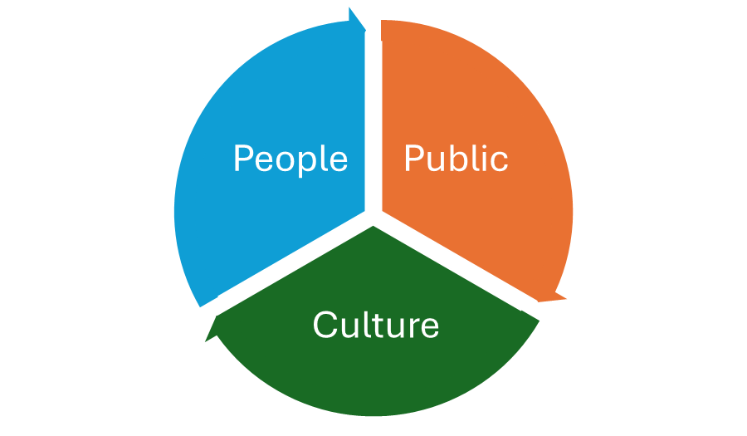

**For our People**

We will, over the next three years:

* Aim to increase the number of Welsh speakers and learners employed.
* Ensure our people have access to tools and resources to use the Welsh they have and develop these skills further.
* Increase opportunities to see, hear and use the language when conducting our business.

We will achieve this through:

* Identifying engagement opportunities and implementing comprehensive recruitment strategies, providing language training programs and offering continuous support to our existing staff.
* Ensure our staff have access to a range of suitable Welsh language tools, resources and opportunities to develop Welsh language skills.
* Increased use of bilingual materials and signage, Welsh language courses and training opportunities for our staff, ensuring all public-facing communications are available in both Welsh and English, and promoting the use of Welsh in meetings and at public events.

**For the Public**

We will, over the next three years:

* Improve the quality of Welsh language services offered.
* Treat Welsh and English equally in terms of language preference and provision.
* Increase opportunities to see, hear and use the language when conducting engaging with / accessing the services provided by the OPCC.

*We will achieve this through:*

* Identify opportunities to use targeted recruitment campaigns and partnerships with educational institutions to recruit Welsh speakers and learners.
* Provide comprehensive training sessions and resources to enhance the Welsh language skills of our staff.
* Ensure that all personnel have access to the necessary tools, such as Welsh language software and reference materials, to support their use of the language in daily operations.
* Increase opportunities for the public to see, hear, and use Welsh when engaging with OPCC services through campaigns that promote the language.
* Address cultural attitudes towards the Welsh language through raising awareness, training, and by fostering an inclusive environment that values bilingualism.

**For the Culture**

We will, over the next three years:

* Use information obtained from monitoring and tracking to identify areas for improvement
* Address internal cultures and attitudes towards the Welsh language.
* Address external cultures and attitudes towards the Welsh language.

We will achieve this by:

* Using information obtained from monitoring and tracking to identify areas for improvement. This will involve regular analysis and reviews of both quantitative and qualitative data to ensure we are making progress and meeting our goals.
* Address internal cultures and attitudes towards the Welsh language by providing training and resources to staff. This will help them develop the necessary Welsh language skills and feel confident in using the language in their daily responsibilities.
* Address external cultures and attitudes towards the Welsh language by increasing opportunities for the public to see, hear, and use the language in their interactions with the OPCC. This will include improving the quality of Welsh language services offered and ensuring that Welsh and English are treated equally in terms of language preference and provision.

**Implementation and Monitoring Progress**

The strategy will be delivered through a Welsh Language Delivery Plan, coordinated by the OPCC’s Welsh language policy lead (WLPL).

We will measure our impact through ongoing analysis and reviews of quantitative and qualitative data.

We will regularly monitor and report internally on our progress against the strategy and publish this progress publicly within the OPCC Welsh Language Standards Annual Report.

**Feedback and Contact Details**

**Mae’r Gymraeg yn perthyn i ni i gyd** - We very much welcome feedback including identifying areas of improvement through contact section on our website. [Contact Us | Gwent Police and Crime Commissioner](https://www.gwent.pcc.police.uk/en/contact-us/contact-us/)

For more information on our continued Welsh Language journey, please visit [Welsh Language | Gwent Police and Crime Commissioner](https://www.gwent.pcc.police.uk/en/transparency/know-your-rights/welsh-language/).