Police and Crime Commissioner for Gwent Decision
PCCG-2025-015 | Police and Crime Commissioner for Gwent Decision Session
Subject | Safer Streets Initiatives Fund 2025/26
Summary | To record the decision of the Police and Crime Commissioner to establish a Safer Streets Initiatives Fund in 2025/26.
DECISION
1. | In order to assist my office in the delivery of my Police Crime and Justice Plan, I have established a fund of £50,000 for distribution to appropriate activities across Gwent. The fund will be known as the Safer Streets Summer Initiatives Fund and will be aligned to my Police, Crime and Justice Plan, key objectives of which are  - Prevent crime and anti social behaviour  - Make communities safer  - Protect the vulnerable
2. | I have decided that this fund will be used to support my role as Police and Crime Commissioner. The fund will be distributed at my discretion with annual decision logs published at the end of the financial year.
3. | Whilst the initial fund will cover the summer months of 2025, subsequent funding rounds will be aligned to future Home Office campaigns such as a winter or springtime equivalent campaign.
4 | In order to monitor progress and provide assurance that funding allocated is effectively meeting the priorities of the Fund, reporting templates will be required to be provided at the completion of the campaign and reviewed by OPCC staff. Staff may also attend site visits with any successful organisation during the funding period.

Jane Mudd, Police and Crime Commissioner for Gwent
I confirm I have considered whether or not I have any personal or prejudicial interest in this matter and take the proposed decision in compliance with my code of conduct.
Any such interests are recorded below.
The above request has my approval.
Signed  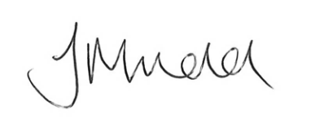 | Date  23.09.2025

Contact Officer
Name | Rob James
Position | Commissioning & Funding Manager
Telephone | 01633 642200
Email | Rob.james@gwent.police.uk
Background papers | Appendix A: Guidance Document

