Violence Against Women and Girls Strategy

2026 - 2029

Date: | February 2026
Author: | Rachel Jones
Responsible Officer: | Ch. Supt. Roberts
Version: | V2

INDEX
EXECUTIVE SUMMARY 3
INTRODUCTION AND CONTEXT 4
VISION AND STRATEGIC OBJECTIVES 5
Our Approach 7
Our VAWG Pillars 7
Pillar 1 – Prepare 7
Pillar 2 – Protect 8
Pillar 3 – Pursue 9
Pillar 4 – Prevent 9
STAKEHOLDER AND ENGAGEMENT APPROACH 9
GOVERNANCE OVERSIGHT AND DECISION-MAKING 9
PERFORMANCE, MEASURES AND EXPECTED OUTCOMES 10
RISKS, ISSUES AND DEPENDENCIES 10
RESOURCES AND FINANCIAL CONSIDERATIONS 11
DELIVERY PLAN AND TIMELINE 11
MONITORING, REVIEW AND CONTINUOUS IMPROVEMENT 11
EQUALITY, DIVERSITY AND INCLUSION 11
APPROVAL AND SIGN OFF 12
GOVERNANCE BOARD AND CHIEF OFFICER APPROVAL 12

EXECUTIVE SUMMARY
Violence Against Women and Girls (VAWG) represents one of the most serious and pervasive threats to public safety, public confidence, and individual wellbeing. It encompasses a wide range of crimes and behaviours - including domestic abuse, sexual violence, stalking, harassment, online abuse, honour based abuse, and exploitation - which are disproportionately experienced by women and girls and are overwhelmingly perpetrated by men.
The scale and severity of harm caused by VAWG is profound and enduring, often involving repeated victimisation, significant physical and psychological trauma, and long-term impact on victims, families and communities. Many of these crimes remain under-reported, particularly within minoritised and vulnerable communities, and are increasingly facilitated by digital technologies.
Against this backdrop, Gwent Police has developed this strategy to provide a clear, coherent and victim-centred framework for tackling VAWG locally, while aligning with national expectations, Welsh Government priorities, and the Chief Constable’s Delivery Plan which focuses on improving trust and confidence.
This strategy sets out how Gwent Police will prevent harm, protect victims, pursue perpetrators and build public trust, through a consistent and trauma informed approach across the organisation and its partners. It is underpinned by the following informed approach across the organisation and its partners:
- Putting victims and survivors first by prioritising safety, dignity and support at every stage of contact with policing, upholding the Victims Code, embedding trauma-informed practice and improving the quality of first response, investigation and ongoing engagement.
- Improving trust and confidence in policing through ethical leadership, strengthened vetting and misconduct processes, transparent performance reporting and a clear commitment to challenging misogyny, abuse and inappropriate behaviour within the organisation.
- Relentlessly pursuing perpetrators, with a focus on high-harm and serial offenders, using suspect-focused and evidence-led investigations.
- Preventing violence before it starts by working in partnership across health, education, local authorities and the third sector to intervene earlier, challenge harmful attitudes, tackle online and technology-enabled abuse, and reduce the conditions in which violence against women and girls is normalised.
- Strengthening capability, governance and accountability to ensure the Force has the skills, capacity, data and systems needed to meet rising demand.
- Delivering a whole-system response, working on strong multi-agency collaboration and shared responsibility.
Through delivery of this strategy, Gwent Police aims to achieve improved safety and wellbeing for women and girls, increased confidence in reporting and better outcomes for victims. Ultimately, this strategy seeks to stop violence before it starts, protect those who are harmed, and ensure perpetrators are held to account to contribute to safer communities and a renewed trust and confidence in policing across Gwent.

INTRODUCTION AND CONTEXT
Violence against women and girls (VAWG) covers a wide range of crime types and behaviours that are disproportionately experienced by women and perpetrated by men. These crimes and behaviours include, but are not limited to:
- Domestic abuse;
- Stalking;
- Sexual violence, including rape and other sexual offences;
- Harassment and sexual harassment;
- Honour-based abuse (HBA), including forced marriage and female genital mutilation (FGM);
- Online and technology-facilitated abuse, including ‘cyberflashing’ and non-consensual intimate image abuse;
- Fatal VAWG, including domestic homicides, femicides, and suicides and sudden or unexplained deaths which occur in the context of abuse;
- Sexual exploitation, including in relation to prostitution and human trafficking;
- Spiking.

We know that men and boys can and do experience these crimes and behaviours, including domestic abuse, sexual assault and stalking and the impact upon them is equally as traumatic as that for women. However, statistically the majority of perpetrators of these crimes and behaviours are men; prosecution data shows that over 90% of those prosecuted for domestic abuse, stalking or sexual offences are male and data from the Crime Survey for England and Wales (CSEW) evidences that women and girls are overwhelmingly disproportionately affected.
This violence may also be intersecting, with victims experiencing multiple different forms of these crimes and behaviours at once, compounding the effects of the abuse and making it harder for victims to recover and rebuild their lives. Abuse and violence may take place on one occasion or continue over many years but all of these crimes take an enormous personal toll on victims and can cause lifelong physical and mental harm which can impact all areas of their lives. Many of these crimes are under reported, or hidden crimes within some communities, and we must find new and innovative ways to detect and prevent them happening. It is also not only adults that may be affected. VAWG also affects babies, children and young people who may be harmed directly when they witness the abuse of their parent or carer.
Policing, and society, must focus on violence against women and girls so that it can be eradicated. Whilst entrenched sexist attitudes are being challenged, new influences such as the spread of misogynistic content online, easy accessibility of violent pornography, and the growth of social media can contribute to a culture that normalises abuse and control. This has led to women and girls often feeling less safe and secure than men, both online and offline.
The harm caused to victims and society is immeasurable and the volume of incidents shocking. The scale has been such that in February 2023, the Home Secretary included (VAWG) within the strategic policing requirement (SPR), which sets out the national threats to public safety. A national threat is defined as:
- “a threat to national security, public safety, public order or public confidence that is of such gravity as to be of national importance; or
- a threat which can be countered effectively or efficiently only by national policing capabilities to counter the threat.
This means that the national policing response to violence against women and girls should be considered on parallel with terrorism and serious and organised crime.
Further, in February 2024, the Government published its first report on the Angiolini Inquiry which investigated the murder of Sarah Everard. Later in that year the National Police Chiefs’ Council (NPCC) declared VAWG a national emergency through a national statement, calling for a whole-system approach to bring together criminal justice partners, government bodies, health and education to collectively tackle the threat, through earlier identification of perpetrators and prevention work. A subsequent second report from the Angiolini Inquiry was published in December 2025 to address public concerns about systemic misogyny and the prevalence of abuse of power. The findings have been a catalyst for policing reform and are a key driver for Gwent Police. The Force remains committed to doing all that it can to ensure that women and girls are safe and feel safe wherever they are. They should also have the confidence to turn to policing whenever they need help.
This victim-centred strategy builds on the work already undertaken by the Force in recent years and outlines how we will prevent and protect women and girls from harm, identify and bring offenders to account and ensure victims and survivors are listened to and supported. Gwent Police alone cannot solve VAWG but we will continue to work in partnership as part of the multi-agency commitment to eradicate violence against women and girls, together with the action and support of all police forces nationally to improve our response, build trust and ensure women and girls are safe in their communities.

VISION AND STRATEGIC OBJECTIVES
Our Vision and aim are to:
- Create a consistent, effective and trusted response to VAWG across Gwent Police
- Create an environment where women and girls feel safe to pursue their lives free of fear and harassment from men, including within Gwent Police
- Provide a coordinated, systemic, and focused approach to tackling the root causes and consequences of gender-based violence
- Build public trust and confidence by ensuring that the Force understands VAWG and is trauma informed.
- Improve Gwent Police’s processes, structures, performance and governance in relation to violence against women and girls
- Ensure Gwent Police is able to meet its local and national responsibilities to victims and survivors of violence against women and girls
- Ensure that victims and survivors are supported on a needs-based basis, that they are listened to and are not judged.
- Ensure that victims are confident in reporting crime and that Gwent Police is supportive, assuring and empathetic.
- Ensure that perpetrators are identified, prosecuted, and prevented from re-offending
- Stop violence before it starts.
On a national level, our strategy aims to meet the requirements of the Government’s new VAWG Strategy: ‘Freedom from Violence and Abuse: a cross-government strategy to build a safer society for women and girls’ (December 2025). ‘Freedom from Violence and Abuse’ is built on three objectives: 1. prevention & early intervention to address the root causes of abuse; 2. the relentless pursuit of its perpetrators and 3. support for all those affect by violence and abuse when it happens. Our strategy reflects these objectives within our approach. We also aim to meet the requirements of the Government’s Policing ‘White Paper’ (January 2026) and its accompanying Performance Framework which places VAWG central to its strategic priorities. The below illustration highlights the interdependency of VAWG with other government areas of focus and priority and its centrality to those areas of focus:
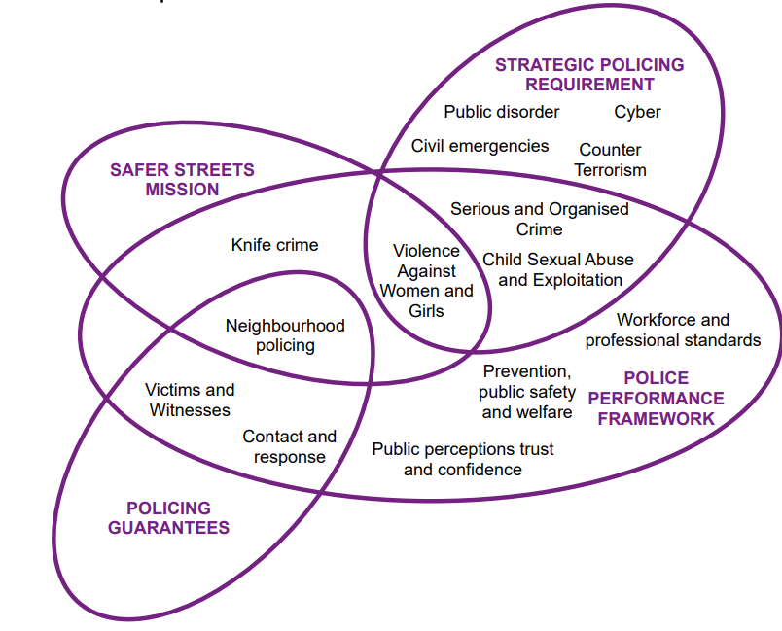
In addition, on a local level our strategy supports and takes account of the Chief Constable’s Delivery Plan and the Gwent Police and Crime Commissioner’s 2025-29 priorities to:
- Prevent Crime and ASB
- Make our Communities Safer
- Protect the Vulnerable
- Put Victims First
- Reduce Reoffending
The overall focus of the Chief Constable’s Delivery Plan is on improving trust and confidence. This is at the heart of our policing strategy, together with a steadfast commitment to put victims first. The experiences and needs of victims will be central to our approach, ensuring that their voices are heard, and their wellbeing is prioritised.

Our 2025 Operational Model review has seen the introduction of a strategic lead for victims at Superintendent level and our Victim Care Unit will play a crucial role in providing continuous support and offering additional services in line with the victim’s wishes. There will be an unrelenting focus on improving our interaction with victims and we will engage with survivors and victims’ to better understand their experiences and shape our services.

We will also safeguard the vulnerable through further enhancing the work of our multi-agency Safeguarding Hubs, and will work collaboratively with partners across the public, private and third sectors to deliver a comprehensive support system for victims. This will include embedding trauma-informed practice, building multi-agency collaborations and engaging victims and witnesses through their journey. By prioritising the needs and voices of victims we aim to build trust and confidence in our policing services ensuring that every victim feels heard, supported, and empowered.

Our Approach
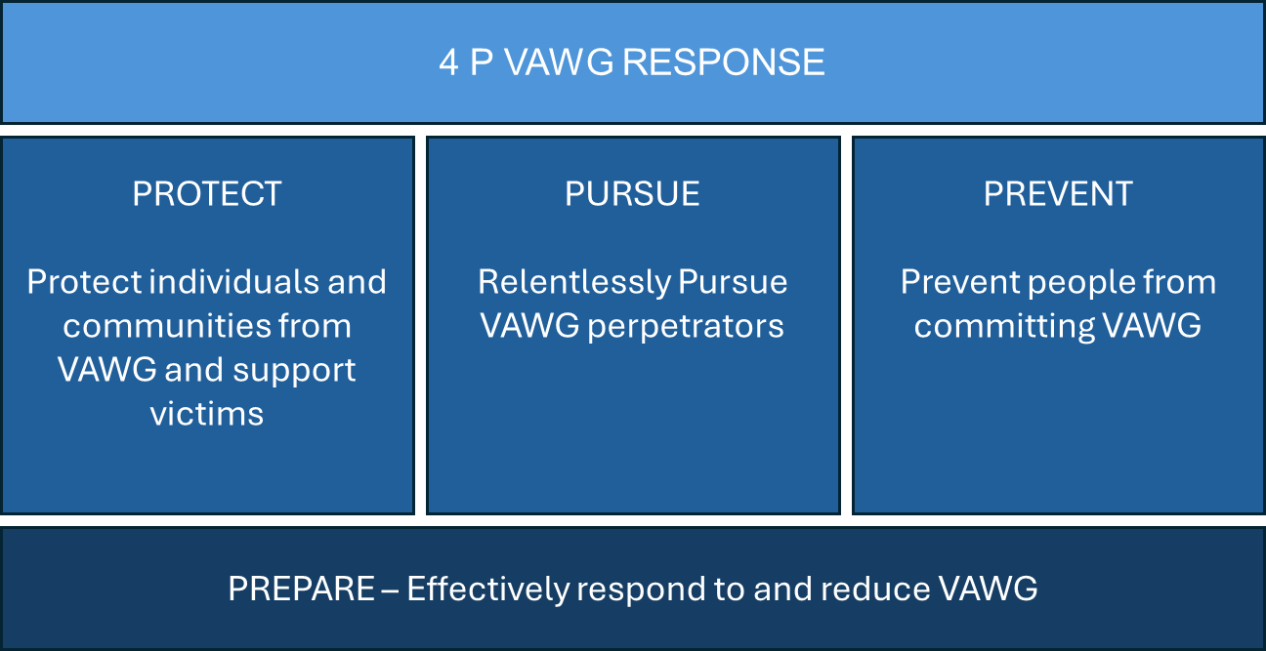
Tackling violence against women and girls is a priority for all officers and staff across Gwent Police. In line with the NPCC VAWG National Framework for Delivery 2024-27, Gwent Police has adopted the ‘4P’ approach above which will be supported by a delivery plan. In addition to the government strategies outlined above, this strategy will also have regard to the Welsh Government Violence Against Women, Domestic abuse and Sexual Violence: Strategy 2022-26 (VAWDASV) and work within the Welsh devolved partnership structures.
This strategy is also cognisant of the following interdependent strategies and principles:
- College of Policing National Policing Culture and Inclusion Strategy 2025 – 2030
- College of Policing Code of Ethics
- Gwent Police Vulnerability Strategy
- NPCC VAWG National Framework for Delivery 2024-27
- Police Race Action Plan (PRAP)

Our VAWG Pillars

Pillar 1 – Prepare
This Pillar focuses on ensuring that the Force is able to effectively respond to and reduce VAWG and sits beneath all three Protect, Pursue, Prevent pillars. We will:
- Continue to build an ethical and trusted workforce that acts with professional integrity through scrutinised vetting, recruitment and acting within the standards of professional behaviour and the Code of Ethics.
- Strengthen the handling of complaints, misconduct and allegations for officers involved in abuse or inappropriate behaviour.
- Demonstrate transparent performance reporting on VAWG‑related outcomes.
- Continue to foster a professional internal culture that addresses VAWG, misogyny and inappropriate behaviours.
- Ensure our officers and staff have the right skills and understanding to enable them to tackle VAWG and that the Force has the right capacity and capability to meet demand.
- Actively seek information and understanding of VAWG perpetrators, victims, locations, barriers, enablers and impacts.
- Ensure we have the right systems, data, processes and technology as enablers to strengthen early identification and disruption and to drive the VAWG response.
- Ensure capability to respond to online and tech-enabled VAWG, using online policing to detect and disrupt offenders
- Continue to embed the principles of Operation Soteria (supporting officers to conduct investigations which are suspect focused) to strengthen Rape and Serious Sexual Offences (RASSO) investigations.
- Maintain an updated and accurate threat picture aligned to the NPCC national threat categorisation to support intelligence-led, proactive policing.
- Ensure transparent performance, accountability and strong governance oversight, clear performance frameworks and continuous improvement mechanisms.
- Ensure the wellbeing of those investigating VAWG and continue to embed trauma-informed policing both externally and internally.
- Reinforce visible, community‑based policing as part of early intervention and prevention strategies through our neighbourhood policing model.
- Improve our whole-system approach by effective multi-agency data sharing and collaboration to ensure early intervention, prevention and co-ordinated safeguarding.

Pillar 2 – Protect
This Pillar focuses on how Gwent Police will safeguard victims, uphold the Victims Code and provide support. We will:
- Continue to develop our victim-centred approach, focusing on keeping people safe using a range of protective options.
- Assess vulnerability and endeavour to recognise intersectional needs.
- Uphold our statutory obligations to the Victims Code and our duties to protect vulnerable or intimidated victims.
- Use protective tools and orders such as Stalking Protection Orders, disclosure schemes and Domestic Abuse Protections Orders (DAPOs) and intelligence-led targeting.
- Embed procedural justice and engage with victims throughout the process
- Ensure better victim care through trauma‑informed policing and upholding national standards for first response and investigation.
- Ensure our specialist officers are fully trained on domestic abuse, sexual violence, stalking, and harassment.
- Work closely with Independent Domestic Violence Advisors (IDVAs) and Independent Sexual Violence Advisors (ISVAs).

Pillar 3 – Pursue
This Pillar outlines how the Force will identify, investigate, disrupt and prosecute offenders. We will:
- Prioritise proactive identification and disruption of high‑harm offenders, including serial domestic abusers, sex offenders and repeat offenders.
- Conduct victim-centred, context-led, suspect-focused investigations and use evidence-led prosecutions.
- Use specialised investigative capability, including our RASSO teams, digital forensics and domestic abuse specialists.
- Use data and intelligence to track and disrupt high-risk perpetrators.
- Ensure investigations are fair, robust and consistent
- Increase focus on online and tech-enabled offending, including tech‑enabled abuse and child sexual exploitation.

Pillar 4 – Prevent
This Pillar outlines how the Force stop VAWG from occurring. We will
- Continue to develop our whole-system approach with other agencies to gain prevention through partnerships, early intervention, culture change and education.
- Actively share information and participate in partnerships in line with the national policing prevention strategy.
- Work with partners to identify risk earlier, problem solve, and focus on building safer spaces and communities.
- Educate our workforce and challenge misogyny.
- Engage with communities to build trust and reduce harm, engaging with women and girls directly to understand lived experiences.
- Work with digital partners and our online police unit to identify and disrupt emerging threats.
- Support primary prevention as requested by partners and lead secondary prevention with VAWG offenders.

STAKEHOLDER AND ENGAGEMENT APPROACH
This strategy has been subject to internal and external consultation in its development.

GOVERNANCE OVERSIGHT AND DECISION-MAKING
Assurance will be provided through a multi-layered approach combining national oversight, independent inspections, local accountability, and performance monitoring. Since being declared a national threat in 2024, VAWG is treated as a national policing priority with dedicated national and local accountability structures.
National Oversight: The Home Office holds Chief Constables to account for their Force's performance on VAWG and child sexual abuse. A dedicated national policing lead for VAWG drives action and strategy, supported by the National Centre for VAWG and Public Protection (NCVPP). The NCVPP coordinates the policing response and acts as a central hub for evidence-based practice and disseminating best practices. Gwent Police, together with other police forces, has aligned our local strategy with the NPCC’s VAWG National Framework for Delivery 2024-27.
Independent Inspection: Gwent Police will also be inspected by His Majesty’s Inspectorate of Constabulary and Fire & Rescue Services (HMICFRS) who will assess how effectively we are responding to VAWG and ensure accountability.
Local Accountability and Scrutiny: The Gwent Police and Crime Commissioner (PCC) holds the Chief Constable to account for Force performance relating to VAWG. The ACC Operations will be responsible for monitoring progress and for scrutinising operational performance while the DCS Head of Crime and Superintendent Investigations and Victims will be responsible for delivery. Oversight will be undertaken through the VAWG, Vulnerability & Serious Organised Crime Board.

PERFORMANCE, MEASURES AND EXPECTED OUTCOMES
Specific victim-centred performance indicators will be set out within the delivery plan sitting beneath this strategy and progress will be consistently reviewed and monitored within Force performance meetings and Force Vulnerability Board.
It is anticipated that Force KPIs will incorporate a combination of local and national measures. For example, the national policing Performance Framework supporting the Government’s Policing White Paper sets out performance expectations for police forces. It supports the delivery of the Home Secretary’s priorities, including halving Violence Against Women and Girls within the next ten years. Measures within the Framework have been grouped into six key topics:
- Prevention, public safety and welfare
- Contact and response
- Investigations and supporting victims
- Workforce and professional standards
- Crime
- Public perceptions, trust and confidence

Nationally, the Government will introduce a new Police Performance Dashboard to enhance the policing system’s ability to self-improve and will publish performance data against their performance framework so that the public can see how their police force is performing, compare it to other forces, and hold their local policing body to account. The performance framework will also be adapted as new priorities emerge.

Gwent Police will also ensure performance monitoring is in line with the requirements of the NPCC VAWG National Framework for Delivery 2024-27.

RISKS, ISSUES AND DEPENDENCIES

There are no strategic risks currently held by the Force in relation to this strategy. Successful implementation of this strategy is dependent upon effective partnership working and ensuring the necessary resources are in place to meet our commitments.
Any risks arising from delivery of this strategy will be treated through the governance structure set out for risks, whereby operational risks will be held, reviewed and mitigated by the local department, and strategic risks will be escalated to the Strategic Risk Register and monitored through the Strategic Improvement Board.

RESOURCES AND FINANCIAL CONSIDERATIONS

The delivery plan will prioritise action and identify any additional resource requirements. It is predicted that Gwent Police will need to continue its investment in specialist training and emerging technologies to maintain capability against technological advancement.

DELIVERY PLAN AND TIMELINE

The delivery plan will be written by the spring of 2026 following approval of this strategy. Once completed, the strategy and delivery plan will be monitored through the Force governance processes to ensure that progress is made in line with the Strategy commitments.

MONITORING, REVIEW AND CONTINUOUS IMPROVEMENT

ACC Operations will own this strategy and scrutinise progress at the Force Vulnerability Board. Assurances will be provided to chief officers and to the PCC through established governance mechanisms. The Force will also develop an effective delivery structure and performance reporting regime to assist in the monitoring of implementation.

The strategy and delivery plan will be reviewed and assessed annually.

EQUALITY, DIVERSITY AND INCLUSION

An Equality Impact Assessment has been completed for this Strategy which aligns with Gwent Police’s duty to promote equality under the Force Strategic Equality Plan. (In draft and pending). In preparing this report, consideration has been given to requirements of the Articles contained in the European Convention on Human Rights and the Human Rights Act 1998.

In 2024-2025, UK policing force strategies for Violence Against Women and Girls (VAWG) have been redefined to emphasise a whole-system approach, integrating equality, diversity, and inclusion (EDI) to address disproportionate impacts on marginalised communities and to rebuild trust. The government and police have initiated a 10-year strategy aiming to halve VAWG crimes, with a focus on preventing men from becoming abusers and supporting victims. Gwent Police recognises that women and girls from minoritised communities, including LGBTQ+ individuals, ethnic minorities, and migrant women, are disproportionately affected by VAWG and face higher barriers to reporting and will do all it can to improve this. Following the Casey Review and Angiolini Inquiry we are also reforming our culture, with intense focus on rooting out misogyny, racism, and sexism within the Force itself. This Strategy will prioritise the relentless pursuit of perpetrators, with a focus on serial and high-risk offenders.
The force is prioritising equality and diversity in all its initiatives by further developing and investing in the Joint Strategic Equality Plan. This will be the backbone of our decision making in recruitment, retention and public engagement. Aligned to our Strategic Equality Plan is our Police Race Action Plan (PRAP) which aims to protect our diverse communities by addressing racial disparities and build trust. The Plan includes workstreams to address culture, vulnerability, and engagement. We are also building a positive workplace culture and are embedding our Culture Strategy and action plan together with ethical leadership strategies.

APPROVAL AND SIGN OFF
In producing this report, has consideration been given to public confidence? YES
Are the contents of this strategy suitable for the public domain (note the strategy should be written with publication in mind)? YES
If you consider this strategy to be exempt from the public domain, please state the reasons: N/A

GOVERNANCE BOARD AND CHIEF OFFICER APPROVAL
This strategy has been presented to the following oversight board: Scrutiny Executive Board
Board chaired by: DCC Nicky Brain
Board date: 2 March 2026
Actions and amendments arising from board decisions: None.

I confirm this strategy has been discussed and approved at a formal Chief Officer meeting.
Signature: 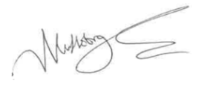 Date: 10 March 2026

