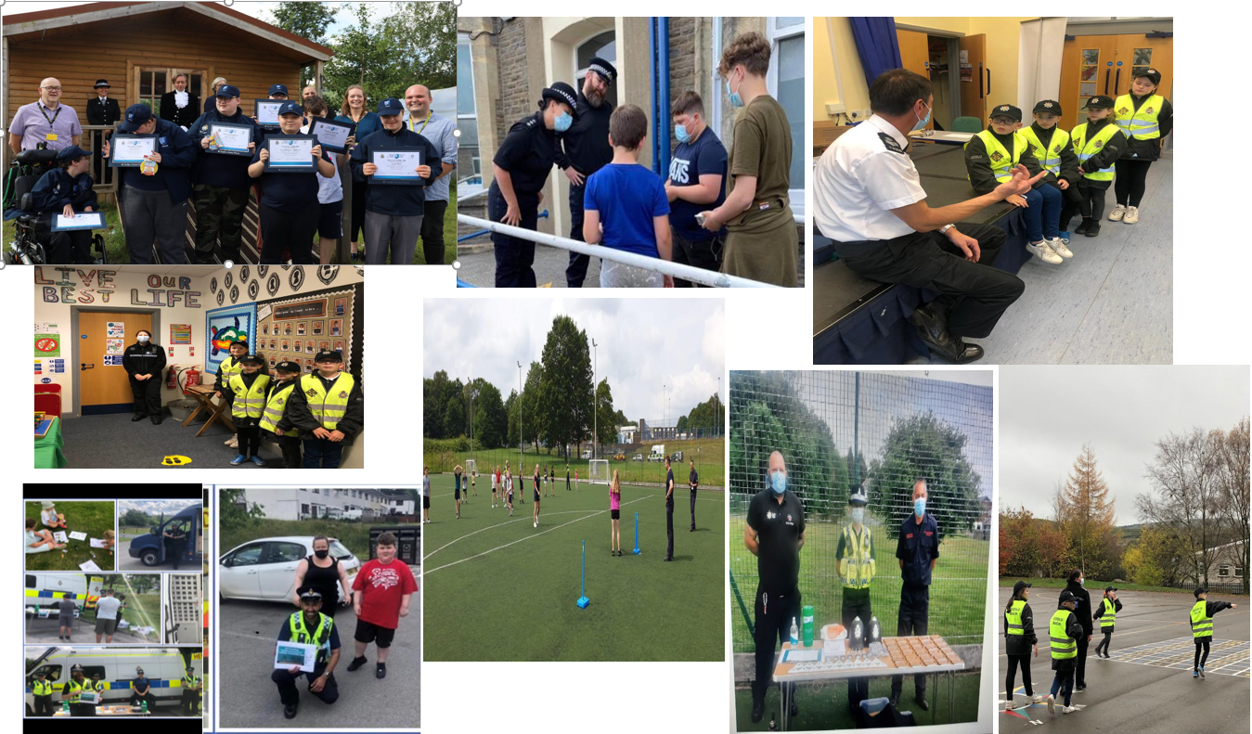

|  |  |
| --- | --- |
| Caerphilly North  Neighbourhood Policing Team  Community Engagement Strategy |  |
|  |  |
|  |  |
|  |  |

**Introduction**

*Without the cooperation of the public, policing in developed democracies would become essentially unworkable. In simple terms, the police service would cease to function without the active support of the communities it serves.*

*Evidence has shown that effective community engagement, targeted foot patrols and collaborative problem solving can significantly increase public confidence in policing activity.*

*By improving public perceptions and increasing trust through fair decision making and positive public interaction, the police service can enhance its legitimacy*

**[College of Policing Engagement Approved Professional Practice]**

**Background and Context**

“To Protect and Reassure”

The Chief Constables’ mission for Gwent Police is to be an outstanding Police Service that is trusted by its communities.

An effective Neighbourhood Policing Community Engagement Strategy will assist in delivering the Police and Crime Commissioners Priorities to

* Keep Neighbourhoods Safe
* Combat Serious Crime
* Support victims and protect the vulnerable
* Increase community confidence in policing
* Drive sustainable policing

This supports the overarching Neighbourhood Policing Strategy with the 3 key elements of

Engaging Communities

Targeting Activity

Solving Problems

The Caerphilly North Neighbourhood Team covers

* **Ystrad Mynach**
* **Bargoed**
* **Rhymney**

Within these sections we have a diverse spectrum of communities, challenges and demands, even so, it is important that we apply a consistent but appropriate response to all our residents and KINS and stake holders via a strong and effective Community Engagement Strategy.

**Benefits of effective engagement**

Evidence has indicated that the potential benefits of effective community engagement include:

* an increase in public perceptions of safety
* a tendency towards a reduction in disorder and anti-social behaviour
* an increase in confidence and trust, and in community perceptions of the police
* an improvement in police officers’ attitudes and job satisfaction.

All of these benefits can have a positive impact on the ability of the police to tackle crime and anti-social behaviour

**The Confidence Cycle**

The confidence cycle is the link between community engagement and increased public confidence in the police. It can facilitate a greater willingness for the public to cooperate with the police.

[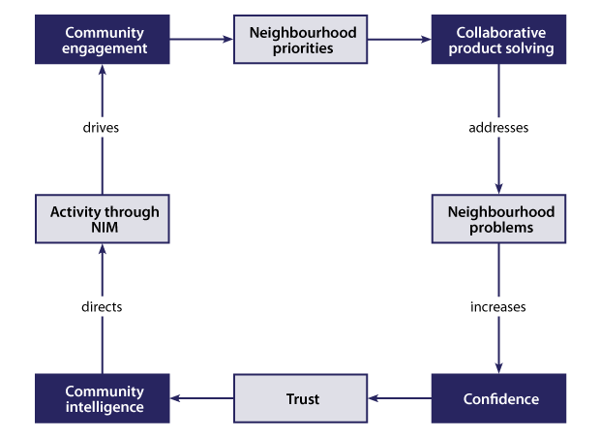](https://www.app.college.police.uk/wp-content/uploads/2013/08/Engagement-and-communication-Confidence-cycle-diagram.png)

**Approach**

As part of the overall Community Engagement Strategy, to improve and embed a strong neighbourhood engagement platform across our sections Caerphilly North Neighbourhood Officers have a structured *Communication Plan* in place.

The Communication Plan sets out a simple and clear approach for all areas on a Daily, Weekly and Monthly basis.

Following this Plan will improve our connectivity and drive our confidence and reassurance levels across the 3 Caerphilly North Sections.

The Plan should be used in conjunction with the **Neighbourhood Toolkit** which offers an array of suggestions for further engagement opportunities.



**Communication Plan**

The Communication Plan will cover the following key points.

|  |  |
| --- | --- |
| **Issue** | What are we engaging about and why? |
| **Audience** | Who are we engaging with? |
| **Message** | What is our key engagement aim and message? |
| **Channels** | How can we best communicate and link in with our hard-to-reach groups? |
| **Ownership** | Who communicates with whom and when? |
| **Timing** | How often will be engaging? |

This Plan will also support staff in achieving the essential elements of engaging with communities in accordance with The College of Policing APP namely;

* officers, staff and volunteers being responsible for and having a targeted visible presence in neighbourhoods
* a clearly defined and transparent purpose for engagement activities
* regular formal and informal contact with communities
* working with partners (e.g., by identifying communities and sharing arrangements for engagement)
* making available information about local crime and policing issues to communities
* engagement that is tailored to the needs and preferences of different communities
* using engagement to identify local priorities and inform problem-solving
* officers, staff and volunteers providing feedback and being accountable to communities
* officers, staff and volunteers supporting communities, where appropriate, to be more active in the policing of their local areas
* community engagement in neighbourhoods should: Provide an ongoing two-way dialogue between the police and the public
* enable the police to develop a better understanding of communities and their needs, risks and threats

Throughout the core work of the communication plan opportunities will be progressed to improve the limited existing engagement with our Black and Ethnic Communities. Support to achieve this will be progressed with our Diversity and Inclusion Teams, Wellbeing Leads and Community hubs.

This will underpin the fundamental activities within this Plan.

**General Engagement**

1. Distribution and Display of NPT Team Posters and Flyers (these must be kept up to date via the Design team with any team changes)
2. Gwent Police NPT Information is kept up to date on Gwent Web Site
3. Team details and team updates are publicised at the front of Station
4. All Staff should know who their Key Individuals and Elected Representatives are and have channels in place to communicate with them.

**Daily**

|  |  |
| --- | --- |
| **Task** | **Task Owner** |
| Review closed ASB incidents for your area during past 24 hrs and ensure a follow up call / visit to the caller acknowledging this call.  Provide feedback and offer thanks for placing the call | **All (split areas amongst staff working)** |
| High Visibility Foot Patrols in line with Demand Pan / Patrol Plan, Visibility Plan and Briefing & Tasking process  9 am and 1 pm NPT Neighbourhood Briefings.  Ensure Patrol Plan and POP Plans are updated to capture this | **All** |
| Review Storm Logs for suitable call deployment | **CSO/Ward & NET** |
| Check Sectional E Mail Folders. Respond & Record accordingly | **All** |
| Update Team Data Capture spreadsheets (e.g., Foot Patrols / Vehicle use, Engagement captures). | **All** |
| Update Communication & Engagement Portal Part A & Part B when required. | **All** |

**Weekly**

|  |  |
| --- | --- |
| **Task** | **Task Owner** |
| POP Plans are updated with a summary of action taken during a set of 6 shifts | **All CSO’s**  **Ward Managers** |
| Minimum of **1** positive tweet for each of the 3 sections | **ORLO Spoc** |
| Partnership Tasking – promote any opportunities and updates of collaborative working via   * Social Media * E Mail / Contact with KINS | **CADRO** |
| Contact in person with local groups – Sporting Groups / Activity Groups etc. identify those that are currently live in your section and visit. Maximise use of the CCBC ‘Cwtsh’ Guide. | **CSO’s** |
| 1 x positive pro-active activity in each section e.g., Speed Checks / Visit to Your Voice Locations / CSW Joint Patrols | **CSO’s & Ward** |

**Monthly**

|  |  |
| --- | --- |
| **Task** | **Task Owner** |
| Identify SPOC for each of your Community Council Meetings. Provide Monthly feedback of activities / positive results / good news stories / emerging concerns and requests for support. Provide this Monthly via   1. **Attendance in person** when able or 2. Written Report **(Newsletter Format)**   **Update Council Meeting spreadsheet on completion and provide pertinent feedback to team** | **CSO’s / Ward** |
| Teams Meeting with MP’s and MS’s to be offered. | **PS / Inspector** |
| Contact with Community Councillors   1. In person / Teams or Via E Mail. | **CSO’s to progress** |
| Police Surgery / Pop Up / Use of Mobile Police Station  *Locations to vary across the sections* | **CSO’s** |
|  | |
| **1 x Community “Respect” Action Day**  Demand Led - High visibility Engagement Event to be arranged on a rota across the 3 sections (1 event per month)  Support from Partners including Safer Caerphilly, Next Generation, Outreach Workers, Positive Futures, Youth Services etc.  1 Collaborative event per month. | **ALL**   * **Rhymney** * **Bargoed** * **Ystrad**   ***(rotate)***  ***Rota in place for rolling 12-month period*** |
| Your Voice Newsletter updates to KINS  Your Voice Update via Twitter | **CSO’s** |
| Inspector Surgeries (1 per section, locations to vary) | **Inspector** |
| Minimum of **1** “Walk & Talk” across 3 sections to be promoted via Twitter | **ALL** |
| Engagement with Schools – link in with SLO for opportunities to visit, promoting positive reinforcement and addressing any emerging issues. | **CSO’s** |
| Community Engagement Spreadsheet to be updated with all activity for the month, | **ALL** |

**Non Time Specific**

|  |  |
| --- | --- |
| **Task** | **Task Owner** |
| Any warrants executed in the areas must be followed up with   1. Tweet 2. Leaflet Drop to surrounding areas 3. Updates to KINS and Elected Members | **ORLO Spoc**  **CSO & Ward**  **PS / Inspector** |
| Any positive Action / Arrest must be followed up with   * Tweet * Further opportunities with Corp Comms where appropriate * Caught & In Court results to be publicised via Corp Comm Spoc. | **Ward Managers** |
| Closure Orders / ASB Convictions / Orders / Dispersal Orders etc to be publicised via ORLO Spoc and Corp Comms. | **CADRO** |
| ASB and Crime Operations to be publicised via Corp Comms | **Inspector** |
| Community Assist Events to be considered where appropriate | **CADRO / Inspector** |
| Joint Publicity with Partners on collaborative work | **CADRO** |
| Regular Leaflet Drops – Demand Led for any emerging ASB or Crime issue. | **All** |
| Open Evenings with Councillors – Presentation from all the team – *Quarterly per section* | **All** |

*The Strategy will be reviewed on a quarterly basis, it is a fluid document and will be adapted to provide the best outcomes for the communities across Caerphilly North.*