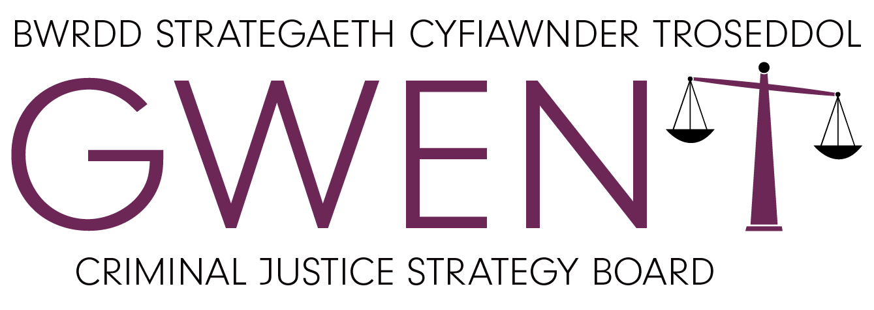
Working in partnership as a Local Criminal Justice Board to provide a fair, efficient, and effective criminal justice system across Gwent.
Justice Strategy 2025-2029

CONTENTS

FOREWORD BY JANE MUDD 2
OUR VISION AND FUNCTION 3
Our Vision 3
Our Outcomes 3
Our Function 3
OUR STRUCTURE AND PRIORITIES 4
Our Foundations 4
SUPPORTING VICTIMS AND WITNESSES SUBGROUP 5
REDUCING REOFFENDING SUBGROUP 6
APPENDIX 1 7
GWENT CRIMINAL JUSTICE STRATEGY BOARD GOVERNANCE FRAMEWORK AND TERMS OF REFERENCE 7
APPENDIX 2 12
VICTIMS AND WITNESS SUBGROUP – TERMS OF REFERENCE 12
APPENDIX 3 14
REDUCING REOFFENDING SUBGROUP – TERMS OF REFERENCE 14

FOREWORD BY JANE MUDD
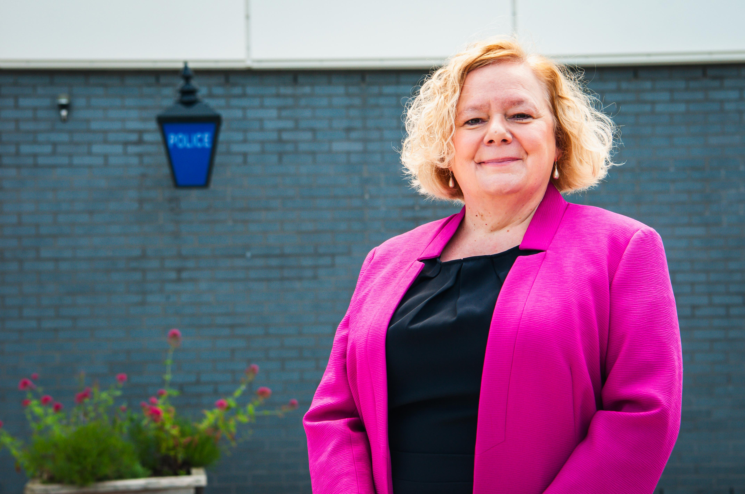

Following my election as Police and Crime Commissioner, I was pleased to take on the role of Chair of the Gwent Criminal Justice Strategy Board.
A long-established collaboration, the Board brings together key partners to provide oversight, drive improvement and increase confidence in criminal justice locally.
When I launched my Police, Crime and Justice Plan 2025 - 2029, I included a focus on providing a strong justice system that puts victims at the heart of what we do and tackles reoffending. The Board is uniquely positioned to support delivery of this element of the Plan.
In May 2025, the Board underwent a process of reflection, renewal and refocus to support collaborative priority-setting for the next period. This Development Day brought members together in-person for the first time since the pandemic. I was delighted to see the energy, engagement and commitment shown by partners, which resulted in the priorities set out within this Justice Strategy - the first of its kind for Gwent. Data-informed and evidence-led, the priorities in this Strategy also reflect both the commitments within the Police, Crime and Justice Plan and specific collective activities agreed with our wider criminal justice partners across Wales.
Since the Development Day, we have implemented a refreshed governance structure, including the establishment of Subgroups to deliver each of the agreed priorities, and worked to develop and embed solid foundations that support our ways of working. We have also agreed a four-year Delivery Plan aligned to the lifetime of the Police, Crime and Justice Plan.
I am very proud of the strong partnership work we have in Gwent. Without this, it would be impossible to deliver on the commitments within this Strategy. We will continue to work effectively together to drive the improvements required, while seeking innovative solutions and utilising cross-partnership engagement to truly deliver a fair, efficient and effective criminal justice system across Gwent.
Jane Mudd.
Chair, Gwent Criminal Justice Strategy Board.
Police and Crime Commissioner for Gwent.

OUR VISION AND FUNCTION

Our Vision
The Police Reform and social Responsibility Act 2011 placed a duty on Police and Crime Commissioners and other criminal justice agencies (Chief Constable; Crown Prosecution Service; His Majesty’s Court and tribunal Service; Prisons; Youth Offending Teams; and the Probation Service) to work together to provide an efficient and effective criminal justice system.
We will fulfil that duty by working in partnership as a Local Criminal Justice Board to provide a fair, efficient, and effective criminal justice system across Gwent.
Our strategic priorities are:
- Supporting Victims and Witnesses: Ensuring quality support is provided to victims and witnesses that meets their needs and improves their experience of the criminal justice system.
- Reducing Reoffending: Ensuring effective approaches that reduce reoffending and promote and strengthen rehabilitation.
The themes of violence against women, domestic abuse and sexual violence (VAWDASV), and children and young people run throughout our priorities.
In addition to the local focus, we will engage nationally at both the Wales and UK levels to shape debate and influence decision making.

Our Outcomes
By delivering against our priorities, we aim to achieve the following local outcomes:
- Public trust and confidence in all aspects of the criminal justice system.
- More positive experiences and outcomes for victims and witnesses at each point of the criminal justice system.
- Person-centred support and effective interventions that reduce reoffending.
- Improved criminal justice performance with quality delivery and outcomes.
- Safer communities that report reduced levels of crime and are less impacted by their experiences.

Our Function
The Gwent Criminal Justice Strategy Board brings together the key partners and senior representatives of criminal justice agencies operating in Gwent, allowing for collaboration and partnership working. The Board is responsible and accountable for the service provided to victims and witnesses, improving the delivery of justice, and increasing public confidence.
The Board has implemented this strategy to set out the local criminal justice direction and areas for improvement to address local priorities. The strategy has been developed through joint local planning and has been aligned to national and regional priorities, with consideration of existing work programmes. Opportunities have been identified to reduce duplication and utilise existing information and governance structures, as well as incorporating learning from others.

OUR STRUCTURE AND PRIORITIES

CJSB PRIORITIES
Supporting Victims and Witnesses • Reducing Reoffending

CJSB
CHAIR
JANE MUDD
SUBGROUPS
(LEADS REPORT PROGRESS TO BOARD)

REDUCING REOFFENDING
SUPPORTING VICTIMS AND WITNESSES

Our Foundations
Our priorities are supported by a set of foundations that will underpin everything we do.
- Operational effectiveness – We will use good quality data and insights to drive improvements in performance and deliver better outcomes across criminal justice processes.
- Public confidence – We will challenge and hold each other to account with honesty and transparency and improve public awareness and understanding of our work.
- Tackling Inequality – We will work together to understand and tackle issues of disproportionality and discrimination in the Criminal Justice System, upholding our commitment to anti-racism.
- Innovation – We will develop our understanding of issues and challenges, along with suitable solutions through effective research and use of innovation.

SUPPORTING VICTIMS AND WITNESSES SUBGROUP
Supporting Victims and Witnesses: Ensuring quality support is provided to victims and witnesses that meets their needs and improves their experience of the criminal justice system.
DELIVERY PLAN

Workstream / Theme | Commitment | Evidence of Success
Victims Code of Practice (VCOP) | Improve compliance with the Victims Code to improve the experiences of all victims across the criminal justice system. | Consistency in compliance with the Code, or visible improvement seen within the data.
Victims Code of Practice (VCOP) |  | Improvement and maintenance of positive rates of victim satisfaction.
Victim Experience | Understand the experiences of victims to inform improvements and consistency across the criminal justice system, including for VCOP. | Victims report improved experiences due to effective engagement and support.
Victim Attrition | Reduce victim attrition by keeping victims engaged throughout the Criminal Justice process. | Consistently low levels of victim disengagement with Criminal Justice Processes.
Victim Attrition |  | The Board is appropriately informed and contributes to improvement processes.
Victim Attrition | Ensure all victims are aware of special measures and provided with a quality conversation ensuring appropriate applications are made. | Data and feedback illustrate an increase and consistently positive engagement with special measures.
Improving Timeliness | Provide oversight of criminal justice performance regarding the timeliness of processes and the impact on victims and witnesses. | Improved timeliness of criminal justice outcomes for victims that contributes to lower attrition rates.
Family and Civil Court | Improve the experiences of survivors within Family and Civil Courts. | Data and engagement illustrate improved experiences for VAWDASV victims and survivors in Family Court.
Children as Victims and Witnesses | Understand the types of offences affecting children to inform decisions regarding support services and interventions. | The Board is informed on the types and levels of harm experienced by children and is better able to engage with and support relevant recommendations.
Children as Victims and Witnesses | Ensure an appropriate and effective service(s) is in place to support children as victims and witnesses who are retained through the Criminal Justice process. | Children (and their families) receive support that enables them to successfully cope with and recover from their experience and navigate their engagement with Criminal Justice processes.
Hate Crime | Ensure an effective criminal justice response to hate crime. | Data and feedback from victims illustrates improved and / or positive experiences of engagement and support throughout criminal justice processes.
Hate Crime | Ensure an effective criminal justice response to hate crime. | Increased victim satisfaction regarding the outcomes of engagement with criminal justice processes.
Hate Crime | Ensure an effective criminal justice response to hate crime. | Data and feedback illustrates improved outcome rates for hate crime cases.

REDUCING REOFFENDING SUBGROUP
Reducing Reoffending: Ensuring effective approaches that reduce reoffending and promote and strengthen rehabilitation.
DELIVERY PLAN

Theme | Commitment | Evidence of Success
Reduce Reoffending | Understand the profile of offending and criminogenic needs of suspects and offenders. | The plan provides clear information on offences committed and criminogenic needs to inform action planning, with performance indicators to measure success.
Reduce Reoffending | Improve the outcomes for people who have offended. | Data shows that interventions are effective and have prevented repeat offending.  Any intervention gaps / issues of effectiveness are identified and addressed.
Improving Timeliness | Provide oversight of criminal justice performance regarding the timeliness of processes and the impact on reoffending for children and adults. | Improved timeliness of criminal justice processes for offenders and a reduction in reoffending.
Engaging with Offenders | Understand the experiences of suspects and offenders to inform improvements and consistency across the Criminal Justice System. | Suspects and offenders report improved experiences and outcomes due to effective intervention and support.
Youth Justice | Facilitate awareness and understanding of youth justice matters and opportunities to support appropriate partnership solutions to issues and / or participation in relevant activities. | Members are engaged with and informed about key youth justice issues and activities.
Youth Justice | Consider thematic youth justice reports, policies and strategies and provide feedback and / or ratification as required by youth justice partners. | Appropriate partnership support is provided to youth justice matters.
Youth Justice |  | Members are aware of the work of youth justice partners and the outcomes / outputs of these activities.

APPENDIX 1

GWENT CRIMINAL JUSTICE STRATEGY BOARD GOVERNANCE FRAMEWORK AND TERMS OF REFERENCE
- VISION
The Police Reform and social Responsibility Act 2011 placed a duty on Police and Crime Commissioners and other criminal justice agencies (Chief Constable; Crown Prosecution Service; His Majesty’s Court and Tribunal Service; Prisons; Youth Offending Teams; and the Probation Service) to work together to provide an efficient and effective criminal justice system.
We will fulfil that duty by working in partnership as a Local Criminal Justice Board to provide a fair, efficient, and effective criminal justice system across Gwent.
Our strategic priorities are:
- Supporting Victims and Witnesses: Ensuring quality support is provided to victims and witnesses that meets their needs and improves their experience of the criminal justice system.
- Reducing Reoffending: Ensuring effective approaches that reduce reoffending and promote and strengthen rehabilitation.
The themes of violence against women, domestic abuse and sexual violence (VAWDASV), and children and young people run throughout our priorities.
In addition to the local focus, we will engage nationally at both the Wales and UK levels to shape debate and influence decision making.

- FUNCTION OF GWENT CRIMINAL JUSTICE STRATEGY BOARD
To bring together the key partners and senior representatives of criminal justice agencies operating in Gwent, allowing for collaboration and partnership working. The Gwent Criminal Justice Strategy Board (CJSB) is responsible and accountable for the service provided to victims and witnesses, improving the delivery of justice and the outcomes for offenders, and increasing public confidence in the local criminal justice system.

- CORE MEMBERSHIP

Agency | Role
Office of the Police and Crime Commissioner (OPCC) | Police and Crime Commissioner  Deputy Police and Crime Commissioner  Head of Strategy  Policy Officer (Criminal Justice)
Gwent Police | Assistant Chief Constable  Detective Superintendent Investigations and Victims  Superintendent Criminal Justice and Custody  Head of Victim Services
Crown Prosecution Service (CPS) | Deputy Chief Crown Prosecutor
His Majesty’s Courts and Tribunal Service (HMCTS) | Head of Crime  Senior Legal Manager, Gwent and South Wales Magistrates Court
Court Based Witness Service | Citizens Advice Bureau Witness Service Area Manager for South Wales and Gwent
HM Prison and Probation Service | Head of Probation Delivery Unit - Gwent
HM Prison and Probation Service | Governor, HMP Prescoed and Usk
Blaenau Gwent and Caerphilly Youth Offending Service | Service Manager
Monmouthshire and Torfaen Youth Offending Service | Service Manager
Newport Youth Justice Service | Service Manager, Newport Children’s Service and Youth Justice
Driscoll Young Solicitors | Defence Solicitor
Legal Aid Agency | Contract Manager
Area Planning Board | Substance Misuse Team Manager
Violence against Women, Domestic Abuse and Sexual Violence Regional Partnership | Independent Domestic Violence Advisor (IDVA) Manager  VAWDASV Regional Advisor  Head of Sexual Assault Services, ISVA Service
South Wales Fire and Rescue Service | Group Manager – Community Safety
Aneurin Bevan University Health Board
Gwent Drug and Alcohol Service | Head of Services

To be fully effective, agencies should ensure representation at a senior level.
Each CJSB member should appoint a deputy of an appropriate grade / role who can, in exceptional circumstances, represent their agency in their absence.
Additional members and standing observers may be co-opted or invited ad-hoc to the CJSB as considered appropriate.

- CHAIR / VICE CHAIR
The Board will be chaired by the Police and Crime Commissioner for Gwent. The Deputy Police and Crime Commissioner will act as Vice Chair in the Commissioner’s absence.
During post-election transition periods, the OPCC Chief Executive will assume the role of the Chair.

- GOVERNANCE OF MEETINGS
The Board will:
- Hold quarterly meetings (as a minimum).
- Be supported by effective subgroups, where necessary, to drive activity on behalf of the CJSB.
- Review the Terms of Reference every four years, or as required.
- Agree a Delivery Plan Framework setting out the CJSB’s strategic priorities how it will meet its commitments and how it will measure success.
- Produce minutes of each meeting and ensure that they are an accurate reflection of the discussion.
Business management functions will be performed by relevant staff from the OPCC.
The OPCC will also arrange administrative support for meetings, which may be provided by member agencies.
Updates on the activities of and outcomes for the Board will be provided to the collaborative Criminal Justice Board for Wales and other relevant meetings as appropriate.

- ROLES AND RESPONSIBILITIES
Expectations on Members
In agreeing to the principles of the CJSB as set out in this Terms of Reference and any accompanying documentation, members are expected to:
- Work towards a shared vision for Gwent through collective and agreed direction and collaboration.
- Actively engage in CJSB meetings and help facilitate a collaborative approach to the local criminal justice system.
- Attend Board meetings with authority to speak on behalf of their organisation.
- Contribute appropriate resources to support CJSB subgroups and / or task groups established to deliver work on behalf of the Board.
- Facilitate data sharing and analysis as appropriate and necessary to support the effectiveness of the Board and its subgroups.
- Refer to the Board, on behalf of their organisation, emerging criminal justice issues for discussion.
- Drive actions between meetings.
- Work with local, regional and national counterparts as necessary to identify and overcome barriers to improving the delivery of justice.
- Respect, at all times, policing, prosecutorial and judicial independence and decision-making.

The Role of the Chair
The Chair should provide strong leadership and establish a collective forum that supports joint working and improves services across the local criminal justice system, whilst respecting the fact that they do not have the authority to manage or direct other individual agencies.
To achieve this, the Chair has the following convening responsibilities, all of which should be carried out in consultation with CJSB members:
- To set, implement and review the CJSB’s Terms of Reference.
- To establish, in consultation with criminal justice partners, an agreed CJSB Delivery Plan and, where appropriate, hold partners to account for its delivery where actions are agreed collectively.
- To ensure the CJSB decides how to engage positively with relevant national programmes.
- To discuss, where appropriate, the strategic plans of individual criminal justice agencies so that interdependence can be identified, and plans can be aligned.
- Where appropriate, to foster discussion of decisions being taken by individual criminal justice organisations which are likely to affect the operational efficiency and effectiveness of the local criminal justice system.
- Where appropriate, to encourage organisations to share findings of inspections / reports where cross-system or a cross-system response would be beneficial.
- To keep under review opportunities to co-fund and co-commission partnership activity, where to do so would be in the interest of the criminal justice system as a whole.
- To encourage collaboration with relevant partners to comply with the Code of Practice for Victims of Crime.
- To engage with Regional Probation Directors on the delivery of Community Payback and commissioning activity as they develop their Regional Reducing Reoffending Plans (and co-commissioning takes place where there are agreements to do so).
- To regularly review the work of the CJSB to ensure that the local CJSB is operating efficiently and effectively.

Sharing Best Practice
The Board is uniquely placed to identify and share best practice and intelligence relating to the efficient and effective operation of the criminal justice system. In addition to the Criminal Justice Board for Wales, consideration for escalation of matters of general importance could include other local Criminal Justice Boards, via the Association of Police and Crime Commissioners (APCC), and via the national Criminal Justice Board Secretariat, based in the Ministry of Justice.
The Board will also make best use of other partnership networks and meetings outside of criminal justice to highlight or refer appropriate matters for consideration.

Data and Information Sharing
From time to time, information may be shared that is for an intended purpose only. There is an expectation that members will abide by any restrictions imposed on the further sharing of data provided to them in their capacity as members of the Gwent Criminal Justice Strategy Board, or through any subgroup working on behalf of the Board.

- WELSH LANGUAGE AND EQUALITY AND DIVERSITY
The Board will actively work to ensure that Welsh language users and their needs are reflected in policy decisions and practices.
It is expected that member agencies will comply with their own Welsh Language Schemes or any Welsh Language Standards applied on them under the Welsh Language (Wales) Measure (2011) in undertaking any work initiated by the CJSB. Partner agencies should, through their policy considerations and decision-making processes, promote and facilitate the use of Welsh language, ensuring the Welsh language is treated equally to the English language and that people in Wales are able to live their lives through the medium of Welsh if they choose to do so.
The Board is committed to tackling inequality across all areas of its business. Building on a commitment to anti-racism, members will work together to understand and tackle issues of disproportionality and discrimination in the local criminal justice system.
Member agencies are also expected to operate in accordance with the Public Sector Equality Duty and uphold their own commitments to equality, diversity and inclusion as set out in their respective equality objectives and plans.

- COMMUNICATION
The CJSB will promote its role, functions and activities to the public in order to raise awareness of its influence and impact in improving the local criminal justice system.
This may include, but not be limited to:
- Publishing information about the Board, its membership, priorities, commitments and Delivery Plan(s).
- Publishing a summary or highlights of activities including for specific or thematic work undertaken via any subgroups.
- Publishing an Annual Report that summarises the work of the Board and its subgroups.

APPENDIX 2

VICTIMS AND WITNESS SUBGROUP – TERMS OF REFERENCE
- MEMBERSHIP
To be made up of representatives from the partner agencies on the Gwent Criminal Justice Strategy Board (CJSB) and other stakeholders that can contribute to achieving the Gwent CJSB vision and the Victims and Witnesses priority.
To ensure, wherever possible, that membership consists of diverse representation to include different and unique perspectives and experiences.
Core membership will consist of representatives from the following:
- Gwent Police
- Crown Prosecution Service
- Office of the Police and Crime Commissioner
- His Majesty’s Courts and Tribunal Service
- Regional VAWDASV Partnership
- Gwent IDVA Service
- Gwent ISVA Service
- Court-based Witness Service
- Commissioned victim services provider
Each Subgroup member should appoint a deputy of an appropriate grade / role who can, in exceptional circumstances, represent their agency in their absence.
Subject matter experts may be co-opted to the group as appropriate.
To undertake, in agreement with the Gwent CJSB, to form a task and finish group to undertake a specific task in relation to victims and witnesses.

- CHAIRS
The Co-Chairs for the Subgroup will be agreed by the Gwent LCJB. The Co-Chairs will be senior members of their organisations who will lead the tactical activity of the Subgroup.

- RESPONSIBILITIES
To bring together a group of key contributors to be able to deliver improvements in line with the priorities identified in the Gwent CJSB Justice Strategy 2025 – 2029.
To own the Victims and Witnesses Delivery Plan (Appendix A) with key performance indicators agreed by the Board and fully understand the performance impact of improvements in delivering the Justice Strategy.
To identify and use best practice and learning points from national / local partners, feedback from audit and inspections and nationally and locally identified risks to problem solve and inform service improvement.
To undertake to complete any pieces of work in relation to victims and witnesses as required by the Gwent CJSB.
To identify areas of inefficiency and duplication and appropriate action to mitigate across all agencies of the CJSB, feeding into wider partnerships where appropriate.
To identify and monitor any areas of risk to successful delivery under the Delivery Plan.
To escalate successes, challenges and any issues in a quarterly CJSB report – to be presented by the Co-Chairs of the Subgroup.

- MEETING ARRANGEMENTS
Quarterly meetings, as a minimum, lasting no more than two hours.
A summary of the key outputs from each meeting will be produced to ensure an accurate reflection of the areas of focus and agreed actions.

APPENDIX 3

REDUCING REOFFENDING SUBGROUP – TERMS OF REFERENCE
- MEMBERSHIP
To be made up of representatives from the partner agencies on the Gwent Criminal Justice Strategy Board (CJSB) and other stakeholders that can contribute to achieving the Gwent CJSB vision and the Reducing Reoffending priority.
To ensure, wherever possible, that membership consists of diverse representation to include different and unique perspectives and experiences.
Core membership will consist of representatives from the following:
- Gwent Police
- HMPPS (Probation)
- Office of the Police and Crime Commissioner
- HMPPS (Prison)
- VAWDASV Regional Partnership
- Gwent Area Planning Board
- Aneurin Bevan University Health Board
- Youth Offending / Justice Services
Each Subgroup member should appoint a deputy of an appropriate grade / role who can, in exceptional circumstances, represent their agency in their absence.
Subject matter experts may be co-opted to the group as appropriate.
To undertake, in agreement with the Gwent CJSB, to form a task and finish group to undertake a specific task in relation to reducing reoffending.

- CO-CHAIRS
The Co-Chairs for the Subgroup will be agreed by the Gwent LCJB. The co-Chairs will be senior members of their organisations who will lead the tactical activity of the Subgroup.

- RESPONSIBILITIES
To bring together a group of key contributors to be able to deliver improvements in line with the priorities identified in the Gwent CJSB Justice Strategy 2025 – 2029.
To own the Reducing Reoffending Delivery Plan (Appendix A) with key performance indicators agreed by the Board and fully understand the performance impact of improvements in delivering the Justice Strategy.
To identify and use best practice and learning points from national / local partners, feedback from audit and inspections and nationally and locally identified risks to problem solve and inform service improvement.
To undertake to complete any pieces of work in relation to reducing reoffending as required by the Gwent CJSB.
To identify areas of inefficiency and duplication and appropriate action to mitigate across all agencies of the CJSB, feeding into wider partnerships where appropriate.
To identify and monitor any areas of risk to successful delivery under the Delivery Plan.
To work with youth justice partners to enable an understanding of key issues and trends to ensure that the provisions across the adult justice system are fit for the future.
To escalate successes, challenges and any issues in a quarterly CJSB report – to be presented by the Co-Chairs of the Subgroup.

- MEETING ARRANGEMENTS
Quarterly meetings, as a minimum, lasting no more than two hours.
A summary of the key outputs from each meeting will be produced to ensure an accurate reflection of the areas of focus and agreed actions.

