Police and Crime Commissioner for Gwent Decision
PCCG-2024-036 | Police and Crime Commissioner for Gwent Decision Session
Subject | Positive Impact Fund 2024/25
Summary | To record the decision of the Police and Crime Commissioner regarding the allocation of funding from the Police and Crime Commissioner’s Positive Impact Fund.
DECISION
1. | Previous publication of Decision number PCCG-2013-123 confirmed the intention to establish a recurrent fund (the Positive Impact Fund) of £10,000 to be distributed at the Commissioner’s discretion.
2. | Funding was provided to a number of projects during 2024/25, a list of which can be found at appendix 1. These grants have been distributed throughout the year.
3. | It is my intention to run the process again throughout 2025/26 and I will adjust the budget accordingly to reflect the financial position at the time.

Jane Mudd, Police and Crime Commissioner for Gwent
I confirm I have considered whether or not I have any personal or prejudicial interest in this matter and take the proposed decision in compliance with my code of conduct.
Any such interests are recorded below.
The above request has my approval.
Signed  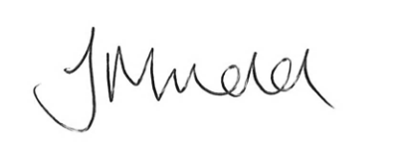 | Date  24.04.2025

Contact Officer
Name | Rob James
Position | Commissioning & Funding Manager
Telephone | 01633 642200
Email | Rob.james@gwent.police.uk
Background papers | Appendix A: List of funding distributed

Appendix 1: List of funding provided from the Positive Impact Fund during 2024/25
Funding Provided | Amount (£)
- Retired Police Dogs of Gwent – Contribution towards charity welfare costs. | £2,000
- 7 Corners Centre – Equipment for a youth focused grass roots project in Abergavenny. | £500
- Special Movers – contribution towards a community engagement event in Rassau. | £500
Total | £3,000

