**Caerphilly North Hate Community Project**

**March 24’**

**Problem Solving & Engaged Communities**

March saw the fruition of an ASB project the Rhymney Neighbourhood team have been working on over the past few months.

**Background for our project**

**ASB Phillipstown, New Tredegar.**

**Hate Crime / Incidents**

Following a noted increase in hate crime and ASB in the Phillipstown area of New Tredegar a Community Assist event was held in Phillipstown supported by Partners, School Liaison officers and members of the Diversity & Inclusion Team.

The work focused on improving cultural awareness, understanding & respect from younger residents within the area.

To support a longer-term problem-solving approach to this issue of hate crime and ASB incidents Caerphilly North Neighbourhood team linked in with the Next Generation team and applied for funding through the ***Inspire******Youth Cymru* initiative** and successfully obtained **£2,500** in funds for an ASB related project.

The team conducted a consultation phase with the community and schools and secured the services of a local artist to work with the younger members of the community in Philipstown to develop some joint external artwork at Phillipstown Community Centre.

Local Community and Councillors were also part of this consultation.

Through Heddlu Bach several pictures were painted by our younger residents to represent the theme of community cohesion, and these were shared with the artist for his inspiration.

**The artwork on the art project commenced 25th March 24’ to provide some positive diversionary activities during the school holidays and finished this afternoon.**

The artist completed the work over the Easter holidays keeping the children positively engaged.

**Phillipstown Community Cohesion Art Project**

**Easter School Holidays March 24’**

**Community Centre**

**Street Artist Steve Jenks**

***Youth Cymru Inspire Funded***

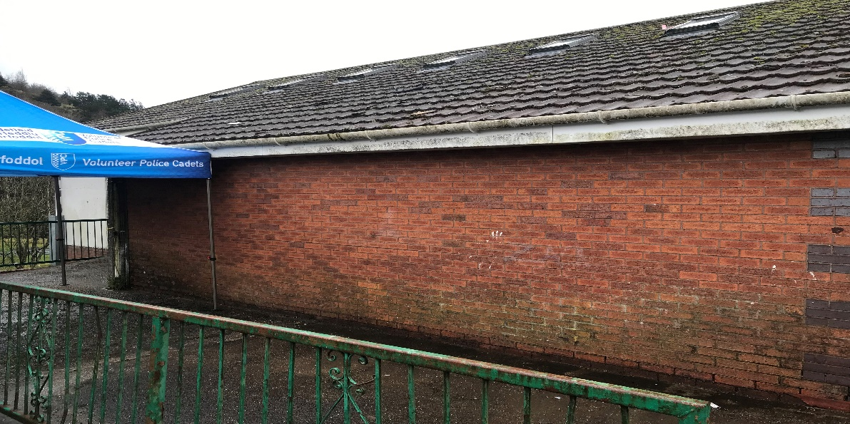

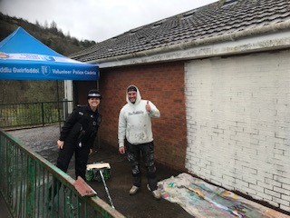 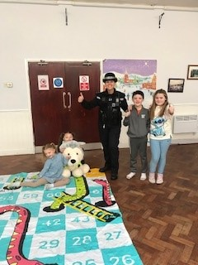

**Visit from our Deputy Chief Constable, Rachel Williams**

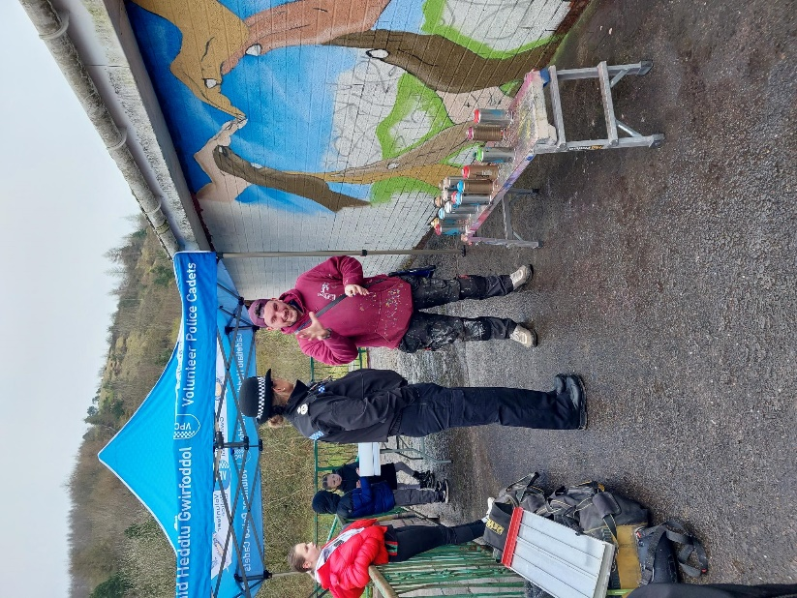 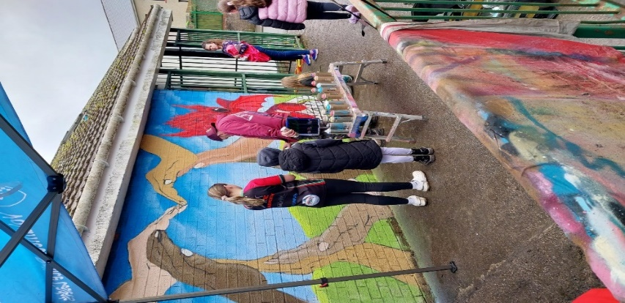 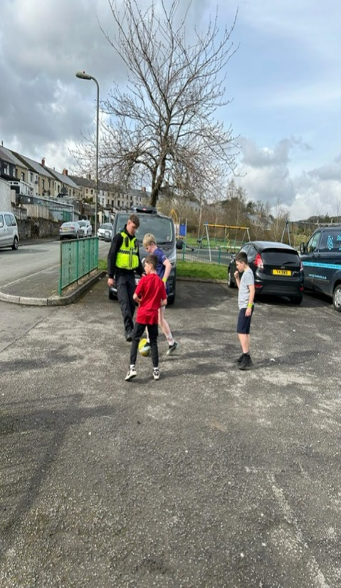

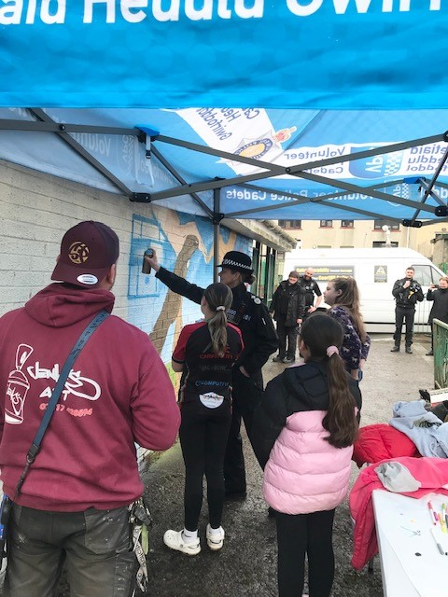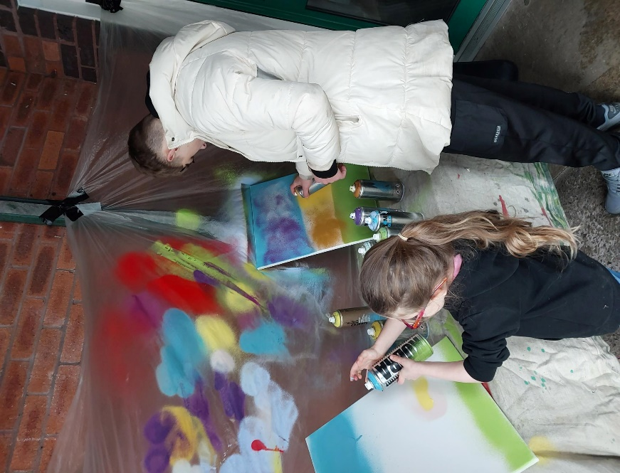

**Final Artwork…**

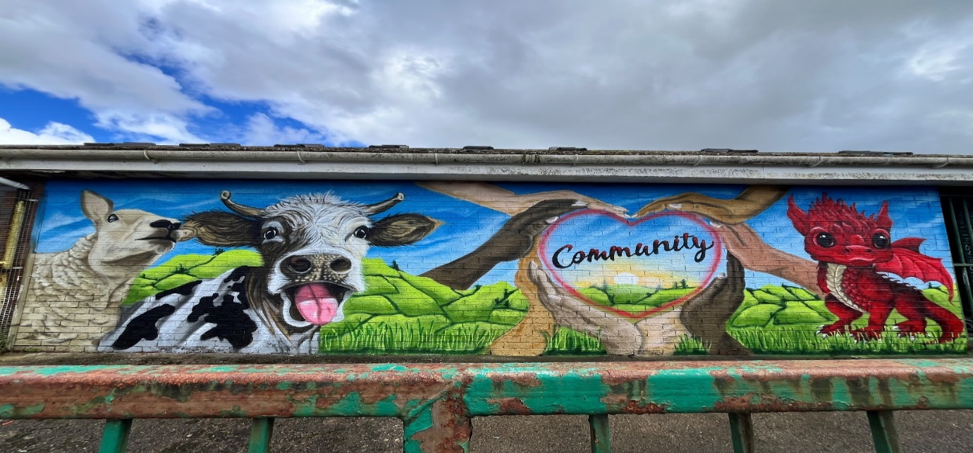

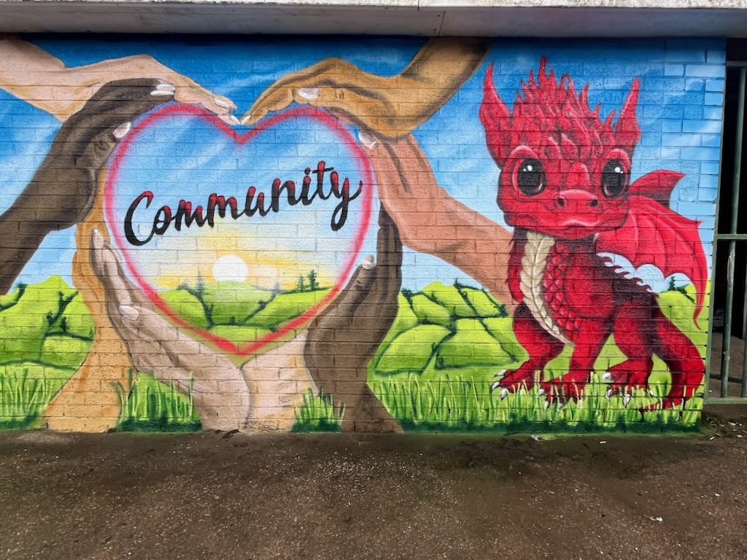

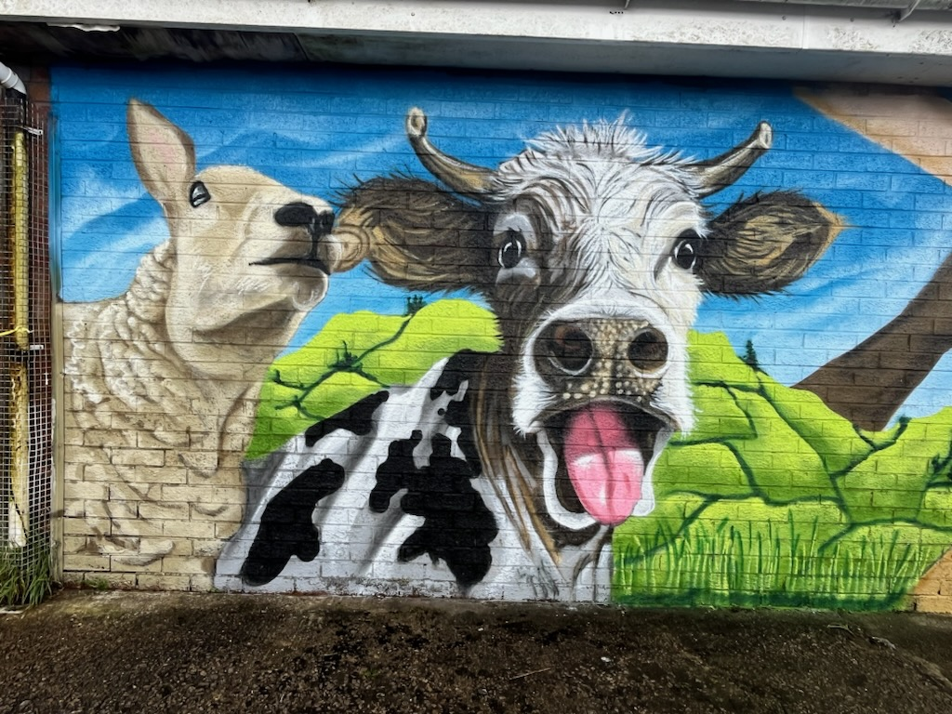

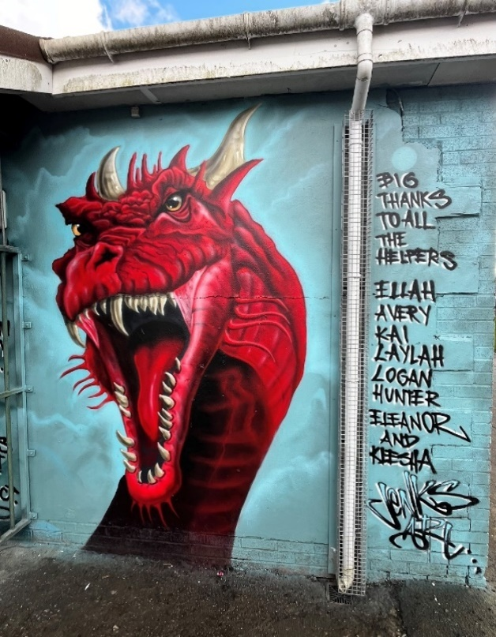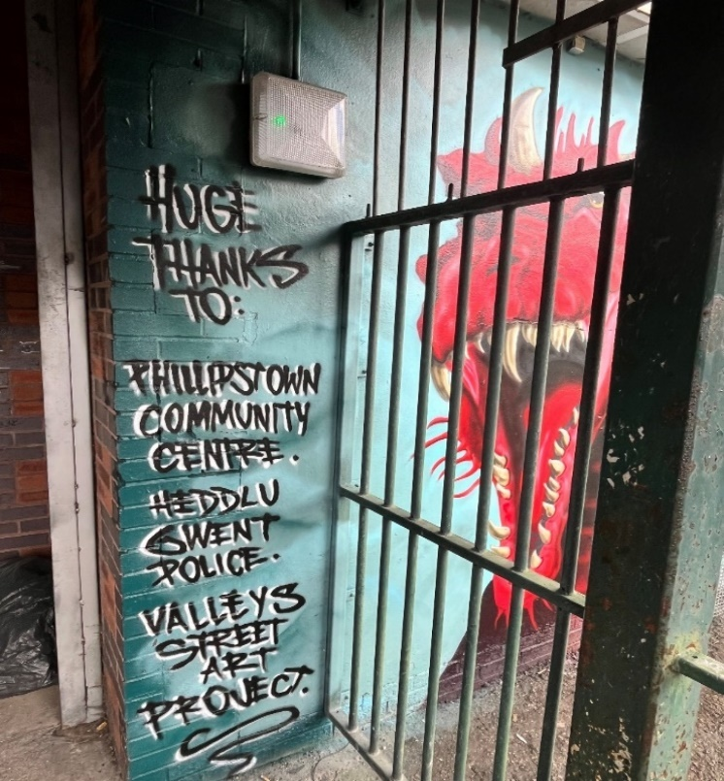

The work has been shared on our Social Media channels and very well received particularly the op Stafford video and I have also ‘received E Mails and written correspondence from our elected representative acknowledging this piece of work which has also been very positive.

