Corporate Communications
Annual report

2022 | 2023

Introduction

This report covers the activity of the corporate communications team from April 2022 to March 2023.

Our first year of the ‘new normal’ post-Covid world brought new challenges as our priorities remained focussed around building and maintaining public confidence.

Professional standards of behaviour by police officers remained high on the national agenda. Locally we set the bar high around our expectations and reinforced this through internal campaigns and consistent messaging. The team also supported out response to some high-profile misconduct cases, and allegations made against retired and current officers through a national newspaper.

The report focuses on how the service has worked to build public confidence in our ability serve Gwent communities, creating a safe place to live, work and visit. The police and crime commissioner’s priorities serve the framework for the report.

Our focus

The police and crime priorities for Gwent until 2025 are:
• Keep neighbourhoods safe
• Combat serious crime
• Support victims and protect the vulnerable
• Increase community confidence in policing
• Drive sustainable policing

These priorities set the framework for our activity and key messaging, focussing on the chief constable’s delivery plan to ensure that the service can deliver its objectives.

Keeping neighbourhoods safe

We have continued providing advice for our residents and visitors on how to stay safe, and to demonstrate the work our teams carry out to make Gwent a safer place to work, live and visit. Some of the key work strands are reflected below.

Christmas is a time of significant activity responding to the increased risks around drink or drug driving and the fatal five causes of collisions, with both a Summer and Autumn campaign, cyber-crime and the team ran a highly successful campaign targeting the key threats.

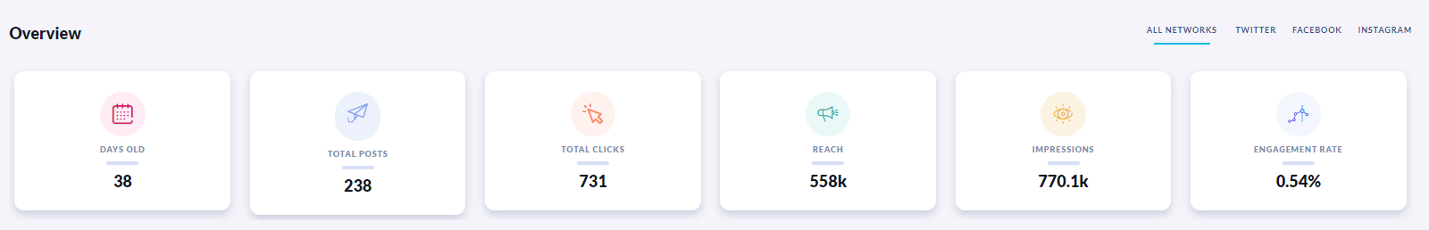

Throughout the year we have delivered campaigns to manage demand, encouraging a shift to digital channels, and focussing on the appropriate use of 999 and 101 channels. We also worked with the force control room to reduce demand on the digital desk by closing comments on social media posts that were likely to attract significant number of comments with no policing purpose. We have experienced a 26% reduction for the digital desk without compromising public engagement. While we cannot say with certainty that this is wholly in relation to us closing comments, with all other demand increasing there is a definite correlation.

Instagram takeovers helped us reach a different, younger audience to raise awareness of cyber-crime. We have run successful campaigns on crypto currency fraud, online romance fraud and general how to stay safe online advice for young people and children.

We have forged a positive relationship with BBC Crimewatch and this year again contributed to their roadshow with both case studies, advice and to ask for help from the public.

The two new LPA communications posts have enabled a more local focus to support neighbourhood policing. This has enabled a greater focus on local inspector vlogs which provide stakeholder updates and allows us to feature content that would not warrant space on corporate accounts such as ASB local updates, warrants exercised and road operations. The support to local social media accounts has led to an increase of 0.5 in the engagement rate on the Newport Facebook account and 0.9 on the Monmouth account.

The posts also enabled us to focus locally on the delivery of the Safer Streets work including targeted security measures, work around sexually exploited women and associated crime in Pill, youth intervention projects.

The presence of the Knife Angel in November 2022 delivered significant coverage of the anti-violence work delivered by the Office of the Police and Crime Commissioner and supported by Gwent Police.

Combat serious crime

The team has worked to promote understanding of the elements of serious organised crime, with media features secured on issues such as modern-day slavery. Wales' hidden modern-day slavery scandal where people are being found sleeping on floors without hot water while working seven days a week - Wales Online

We have also promoted the outcomes of major cases involving drug dealing, cannabis cultivation and violent crime to both reassure the community that we take a robust approach to investigating and prosecuting these criminals and as a deterrence.
We work with lead investigators to ensure that when significant cases are nearing sentencing that we have a media package available to ensure Gwent Police features heavily in any subsequent coverage.

We secured extensive coverage across local and national media, for example: South Wales £4.5m 'organised' drugs gang jailed - BBC News

We have also developed social media-based campaigns tackling areas of organised crimes such as online fraud, romance fraud and digital security to help our communities stay safe.

We supported work around county lines from sharing details of online events to help parents spot the signs of exploitation to the work of officers in Newport targeting potential travel routes and educating key individuals on how to spot the signs.

Support victims and protect the vulnerable

We have continued our work to support the Victim Care Unit and the work of the survivor engagement lead. This work included promoting targeted victim experience surveys to creating internal training videos. We also marked the first anniversary of the VCU and the Victim Reference Group externally to build confidence in our services and attract new members to the reference group.

Recognising that while hearing from survivors of domestic abuse, particularly around their experience of their interactions with us is extremely powerful it can also be re traumatising. We therefore worked with survivors to capture their experiences in a sensitive way for internal use for internal training with officers.

We also promoted our participation in Op Soteria Bluestone as we became one of police 14 services to participate in a project designed to transform the policing response to rape and serious sexual offences (RASSO). Again, the focus was building confidence in our desire to improve our service to victims of these serious offences.

White Ribbon Day provided an opportunity for members of the Victim Reference Group to acknowledge the men who did stand up and support them. Against a backdrop nationally of police perpetrated violence against women and girls it was important to acknowledge that there are men who go the extra mile to support women experiencing domestic abuse or violence.

Internally, culture change around professional standards of behaviour was already high on our agenda and this year brought an additional focus on upstander behaviour. Building on an evidence-based project developed by the Violence Prevention Unit targeting the night-time economy, we created an internal campaign providing colleagues with approaches to make interventions should they be party to any inappropriate behaviours. The campaign ‘Step in, Step up and Set the tone’ offered practical approaches in a high impact pop art graphic.

The 2023 staff survey indicated that more than 88 per cent of respondents felt confident that they could now report inappropriate behaviour, and 83 per cent confirmed that they had not been subjected to behaviour that they considered unacceptable. A report from the police inspectorate in 2022 found of Gwent Police that “the force’s standards are promoted by the senior leadership, and reinforced in messaging, governance meetings and training. “Almost all staff we spoke to were aware of the behaviour expected of them and spoke positively about the commitment of the force leadership.”

The team has also carried out significant work around misconduct cases, reinforcing the message internally and externally that we will not tolerate behaviour by officers or staff that breaches the trust of the public or colleagues.

Increase community confidence in policing

Work across the corporate communications portfolio aims to build community confidence in policing:

- Our proactive media work tells the story of Gwent Police works on behalf of the population to prevent and tackle crime. During the year we once again shared more than 1,000 releases providing updates on the work of our officers, incidents or successful court outcomes. We celebrated the achievements of our colleagues and reinforced the work of our teams across portfolios and geography.

- We responded to more than 2.8k incoming media enquiries through our press desk and on-call service which operates 24/7, up 25% on the previous year. This ensures local, regional and national media are able to provide timely updates on incidents and reinforce messaging from Gwent Police.

- We have shared our strong position on the high standards of behaviour we expect from our colleagues and demonstrated internally and externally the action we have taken to challenge those who do not live up to these expectations.
- Improving support for local teams has enabled more content aimed at reassuring on highly localised community issues increasing their relevance to the audience.
- Operation Uplift has also enabled us to demonstrate the real increases in resourcing that we are bringing to the people of Gwent.
Our recruitment campaigns took a playful approach to myth busting the negative comments left in response to recruitment posts. As well as bringing the everyday contribution of our officers to life it countered some of the incorrect perceptions of policing held by our community. The campaign has helped us to successfully recruit to our target number of officers.
- Work on the estates portfolio has provided reassurance around our commitment to maintaining a local presence in key areas for example working with key stakeholder in Abergavenny to keep them up-to-date with the development of our base in the town. We also managed an engagement event for local residents and stakeholders around our development proposals for the old HQ site which was well received.

- Our work with the force control centre to reduce the demand into the call centre has focussed on reassuring the public that we will be there when they need us and to invite them to work with us to use all available methods of contact.

- Behind the Badge 2022 was a hugely successful event when we were able to meet our community face to face once again. We also managed a highly successful social media campaign around the event to enable the wider community to be involved:
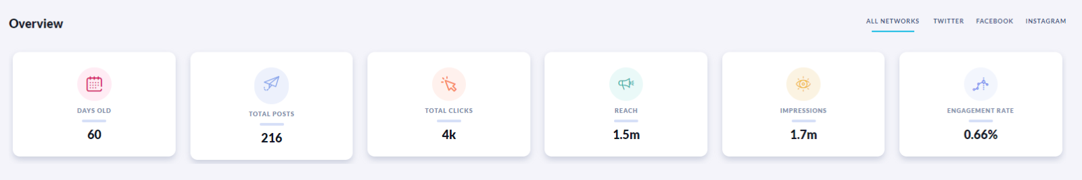
- Training colleagues whether on our social media handling platform Orlo, and on how to get the best from social media or delivering media training on our PIP2 courses the team helps the service have better conversations with the public around the work we deliver for them.
  - 118 officers received basic social media training to improve the quality of our content
  - A new training package supports neighbourhood officers to better engage with audiences via social media
  - Training for new and existing Digital Contact Desk operators focuses on customer service and good communication tactics.

Driving sustainable policing

‘Show us what you’ve got’ recruitment campaign
This recruitment campaign was introduced towards the end of Op Uplift when it was established that applications were dwindling.
Policing nationally was experiencing a challenging time with some negative stories in the media. Additionally, we were facing local criticism around the public's perception of how a modern police service operates.

“Show us what you’ve got” used genuine comments from our social media channels, myth-busted them with facts and challenged the public to join us and do better.

This approach targeted the audience beyond those thinking only of policing in terms of ‘helping the public’ and associated benefits by providing a real take on the role applicants would play. By introducing a playfulness that encouraged more engagement, it would also alter the public’s perception of how modern policing is carried out. Additionally, we identified a third potential benefit that it would help to boost the morale of officers who frequently see criticism on our platforms and would benefit from our defence of them.

The new concept and theme worked well across all our social platforms, including TikTok. This allowed us to be more engaging and challenge our audience in taking a more active role.

The design team created graphics and assets to accompany the new campaign and combine our look with something that was eye-catching and engaging.

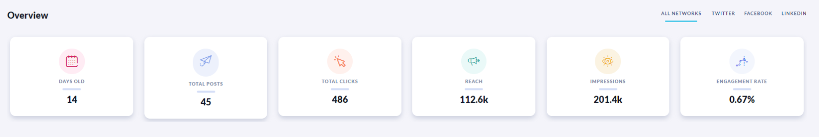

Applications eventually surpassed Op Uplift targets, with 1,700 received in total over the whole period and over 500 new officers recruited.

Move to new HQ

January 2022 saw the move to our new headquarters building. The team worked with Estates to support the move schedule providing virtual tours for those who could not visit in person, a user guide to the building and providing regular updates on our progress. External stakehdolder engagement also formed part of the plan, along with media involvement to support public messaging.

Internal communications

Our internal communications journey so far

Having built the foundations of internal communications following the forming of a dedicated team, the past year has seen this evolve to further meet the following strategic objectives:
- connect our people to the force mission, vision and values
- engage our people in delivering organisational priorities and support cultural change
- positively influence our people’s behaviours and engagement, in turn improving organisational performance.

These link directly to objectives set out within the chief constable’s delivery plan. Setting this direction has enabled us to focus our internal communications and engagement activity in areas that we feel will have the greatest impact on our performance, people, and culture, and therefore public confidence.

Poppulo – an external internal communication software programme – continues to support effective targeted email communications, while providing robust analytics to help tailor future content. We continue to receive positive feedback on the weekly Bulletin, a personalised curation of need-to-know news and updates, cutting out the volume and noise that is sometimes experienced on The Beat.

Data also tells us we’re also consistently performing above industry standards for our targeted email communications:

Internal communications benchmark | Government and public services | Gwent Police
56.5%  Average open rate | 48.52%  Average open rate | 58.98%  Average open rate
14.61%  Average click to open rate | 14.61%  Average click to open rate | 14.61%  Average click to open rate
4.96%  Average click rate | 4.66%  Average click rate | 8.62%  Average click rate

We’ve also restructured some elements of The Beat – our intranet platform – to cut through the noise and allow colleagues to effectively access important operational information or changes.

Creating a learning culture – two new digital colleague magazines

We have developed two new bespoke magazine-style digital publications for colleagues this year called ‘The PSD Times’ and ‘The Investigator’. Both e-magazines focus on summarising key learnings from investigations and inquiries to share best practice and promote a learning culture across the organisation.
‘The PSD Times’ also aims to increase transparency and openness in relation to how our Professional Standards Department operates, and to give colleagues confidence in how reports and investigations are managed.
Both publications have been well received. Total open rate of the last published edition of ‘The Investigator’ was 87 per cent, and a readership survey included in ‘The PSD Times’ reported that 100 per cent of respondents plan to read future editions.

Supporting performance delivery

The team has worked to support improvements in service delivery to benefit our communities. From comprehensive communications around our burglary pilot to our participation in the Home Office productivity research, the team has worked to support officers improve our offering to the local community.

PDR

This year’s PDR response was the highest to date at 88%.
Our approach was to separately target teams and line managers, with a focus on:
- Supporting progression and identifying training
- Team members’ wellbeing
- Providing formal recognition of good work
- Setting objectives that meet organisational growth
- Reminding colleagues of the additional functions a PDR has to offer such as: submitting feedback, accessing coaching and mentoring and more.
We reminded colleagues of the PDR link to pay progression and promotion and shared a guide put together by the design team on completing them, as well as advertising workshops. Timely comms were shared reminding colleagues of check ins.
Finally, we shared the case study of a line manager who successfully manages her PDRs and how positively her team receives it.

The approach was supported by innovative work by the Design team who created a process map and toolkit:

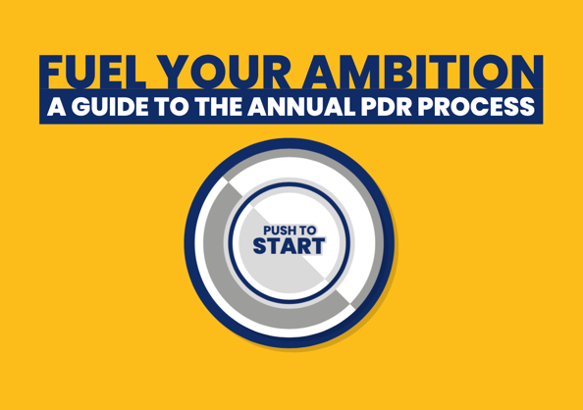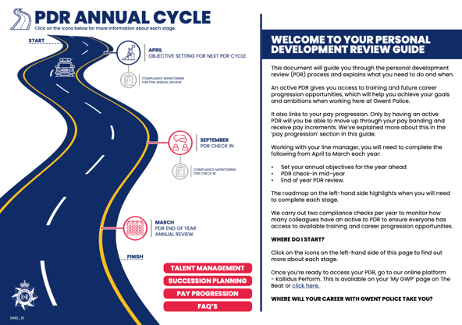

Staff survey

This year’s employee survey had the highest response yet at around 40%.

Regular communications focused on giving colleagues a voice and a channel to make a difference with a survey that was simpler and quicker to complete than previously. We also assured anonymity as we knew that was a barrier in some cases.
The information was shared via force news on The Beat, targeted emails via Poppulo and targeting within the Bulletin.

Performance

This section sets out analytics that help us measure our success across key communications channels.

Media

Media snapshot:
- The team dealt with 2,804 queries this year – up nearly 25 per cent on the previous 12-month period.
- We handle on average 234 media queries per month – a rise of 46 on the previous year.
- Nearly 13,000 media references to Gwent Police across online, print and broadcast formats.
- Welsh media and hyperlocal outlets dominate, with the South Wales Argus again making the most enquiries to the team.

Enquiries
The communications department responded to 2,804 media queries between April 2022 and March 2023.
Overall, this is a rise on the previous 12-month period of 553 (2021/22 – 2,251) and equates to an increase of nearly 25 per cent in volume. The demand was not spread evenly over the year, but instead demonstrated real peaks with two months seeing over 100% increase in enquiries. While major stories were running in these months a closer inspection demonstrates that the increase was across a high number of smaller issues rather than one issue dominating.
As shown by our key outlets, most of our enquiries come from outlets based in Wales and this highlights the importance of focussing on issues that affect our communities.
Key outlets
The South Wales Argus, based in Newport, submitted the most enquiries into the communications department within the 12-month period, followed by Wales Online and BBC Wales.
Caerphilly Observer, one of our key hyperlocal outlets, also appear on this list, ahead of ITV Wales and the news agencies South West News Service (SWNS) and the Press Association (PA).

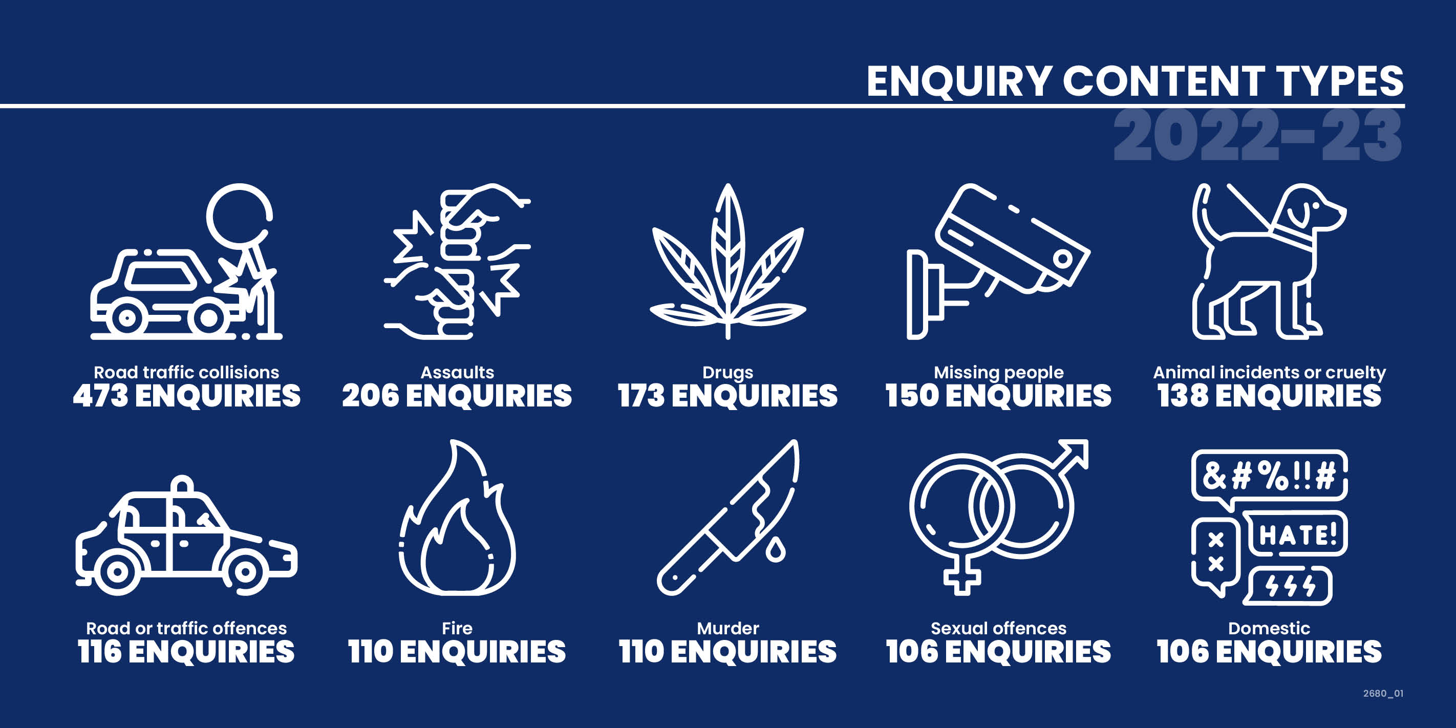

The most frequent subject by query for 2022/23 was road traffic collision (RTC) with 473 logged enquiries. This category accounts for more than one sixth of all the enquiries that the team received in the 12-month period. The top ten account for more than 50% of the queries received.

The Monmouthshire Tindle titles – Monmouthshire Beacon and Abergavenny Chronicle – were among the most regular outlets to submit queries into the team followed by BBC Radio Wales, the most regular outlet from radio broadcast.
This shows that Welsh-based outlets, including regional centres of national broadcasters and hyperlocal news establishments, were the dominant force for enquiries between April 2022 and March 2023.
Of the national media, including tabloids and their respective news website, the most regular outlet to contact the communications department was the Daily Mail or Mail Online.
Releases
Despite the substantial rise in enquiries from the media, the actual number of releases or statements provided by the team remained similar at just over 1,000. Despite the increased demand the team has continued to proactively share positive outcomes and achievements to build public confidence, as well as providing updates on incidents.

The future

Industry predictions for the year centred around concerns over the lack of funding for traditional media (print and on-line) and increasing news avoidance by audiences, particularly on major issues. Research indicates that these outlets will be looking to focus on explainer content, Q&A formats and inspirational content. Positive news was a less popular option. The media team will therefore focus on exploring how we approach this landscape to share our positive stories through these new approaches.

Social media

Account | Followers | Account Impressions | Post Impressions | Account Reach | Post Reach | Link Clicks | Pub. Posts | Engagement
Twitter
Gwent Police | 85.6k | - | 5.4m | - | - | 38.2k | 1.2k | 1.06%
Heddlu Gwent | 557 | - | 84.1k | - | - | 1.6k | 984 | 2.91%
Facebook
Gwent Police | 156.9k | 58.2m | 54m | 28.1m | 50.6m | 275.1k | 1.4k | 0.98%
Heddlu Gwent | 469 | 80.9k | 78.2k | 62.3k | 77k | 623 | 1.2k | 1.1%
Instagram
Gwent Police | 19.6k | 2.1m | 1.4m | 1m | 1.3m | 1 | 325 | 2.73%

Total link clicks during period | 319.1k (up from 296.6k)
Total reach during period | 29.2m (down from 36.2m)
Total followers during period | 263.1k (up from 249.2k)
Total inbound messages (DM & Comments) | 152.3k

Comparing our engagement rate across corporate accounts we have seen an increase in our engagement:

Account | 2021-22 | 2022-23 | Industry standard of ‘Good’
Twitter |  |  | 0.122% for the top 25%
Gwent Police | 0.82% | 1.06%
Heddlu Gwent | 1.43% | 2.91%
Facebook |  |  | 1
Gwent Police | 0.91% | 0.98%
Heddlu Gwent | 1.1% | 1.1%
Instagram |  |  | 1-3
Gwent Police | 2.62% | 2.73%

Our reach has declined over the year which could align with the removal of comments from some posts. However, as these comments served no policing purpose having them shared across further accounts offered little value.

The increase in engagement is more easily delivered with a smaller audience, but the team has also increased its conversational approach with followers to drive this trend.

Comparing our click through rate across corporate accounts we have seen a mixed change but our Facebook audience have increased in clicks, indicating that this audience is more receptive to links:

Account | 2021-22 | 2022-23
Twitter
Gwent Police | 46.2k | 38.2k
Heddlu Gwent | 1.5k | 1.6k
Facebook
Gwent Police | 230.6k | 275.1k
Heddlu Gwent | 608 | 623
Instagram
Gwent Police | 9 | 1

LinkedIn

We have seen an increase in our use of LinkedIn to target a different audience this year. With a big push on recruitment via the channel we have seen an increase in engagement with our staff roles shared.

We have targeted the professional audience offered by LinkedIn to drive engagement with selected recruitment campaigns.

TikTok

Our TikTok account started in July 2022 after conducting we researched other forces use the platform to effectively engage with different audiences.

The aim of the account has always been to educate and inform the public about the police service and to engage with a younger audience (16 to 25).

In the past year, we have posted 41 times and currently have:
- 4,999 followers
- 25.6k likes.

TikToks have a longer life span which means that our videos are constantly being viewed - even when they're a year old.

The algorithm is different to that of the other platforms. On TikTok, videos have a longer life span, meaning that viewers can see videos that are potentially up to 12 months old. They are shared organically and presented to people based on trends and previously viewed topics and videos. The number of followers is therefore less relevant measure on this account.

We aim to share important messages around topics that matter to the younger target audience, such as road safety advice, sexual abuse awareness, and general advice. We also share some recruitment videos attempt to get involved in TikTok trends.

TikTok road safety campaign (ongoing):

Working with a member of the team we have produced educational videos on:
- drink/drug driving
- keeping safe on the road in the winter
- the fatal five
- motorcycle safety.

We also gave a tour of our newest RPSO vehicle as part of this campaign.

The campaign is an ongoing one and we plan to get more content around myth busting and the stats of road safety.

So far the campaign has delivered:
- reach: 270,141
- likes: 8,114
- comments: 393
- shares: 847
- saves: 670

This has provided us with a reach to an audience that isn’t accessible through our other social media channels, and has placed an emphasis on creating content with a longer life-span.

TikTok followers | gender

Male followers | Female followers
66% | 34%

TikTok followers | age

18 - 24 | 25 - 34 | 35 - 44 | 45 - 54 | 55+
27% | 33% | 23% | 12% | 5%

As you can see, we have a broad range of followers but to reach more of our target audience (16 – 25) we may need to proactively target or tweak content.

TikTok trends are a good way to engage with younger audiences. However they must align with our values and purpose.

Specialist channels

Account | Followers | Post Impressions | Link Clicks | Pub. Posts | Engagement
Twitter
Specials | 2.5k | 70.2k | 171 | 45 | 1.11%
Nxt Gen | 2.7k | 122.8k | 74 | 132 | 1.38%
Rural Crime | 1.7k | 207.8k | 107 | 135 | 1.54%
Operations & Support | 5.6k | 230.7k | 75 | 103 | 0.94%
Dog Section | 9.3k | 781.3k | 39 | 91 | 3.2%
Cyber Crime | 2.3k | 150k | 7.2k | 555 | 5.54%
We Don’t Buy Crime | 567 | 112.2k | 55 | 140 | 1.13%

Local channels

Account | Followers | Post Impressions | Link Clicks | Pub. Posts | Engagement
Twitter
Caerphilly | 5.2k | 1m | 1.4k | 707 | 0.87%
Blaenau Gwent | 4.3k | 890.7k | 643 | 884 | 1.08%
Newport | 5.7k | 639.9k | 957 | 580 | 0.97%
Torfaen | 3.8k | 406.6k | 422 | 381 | 0.95%
Monmouthshire | 5.4k | 479.7k | 964 | 235 | 0.97%

Single online home

News and vacancies remain the two most popular areas on the site. The bounce rate (the rate at which viewers leave the page) remains high for both areas – five minutes plus for the recruitment page demonstrating a high level of engagement. At present the national team has withdrawn the full analytics available while a technical error is resolved.

Conclusion
The team continues to progress the development of communications that support the delivery of the police and crime commissioner’s objectives in line with the chief constable’s delivery plan. With an increased focus on an evidence-based approach to what works, and what works for Gwent we aim to continue to deliver successful campaigns and channels internally and externally for the coming year.

FINANCIAL CONSIDERATIONS
N/A

PERSONNEL CONSIDERATIONS
N/A

LEGAL CONSIDERATIONS
N/A

EQUALITIES & HUMAN RIGHTS CONSIDERATIONS
- This report has been considered against the general duty to promote equality, as stipulated under the Joint Strategic Equality Plan and has been assessed not to discriminate against any particular group.

- In preparing this report, consideration has been given to requirements of the Articles contained in the European Convention on Human Rights and the Human Rights Act 1998.

RISK
N/A

PUBLIC INTEREST
- In producing this report, has consideration been given to ‘public confidence’? Yes
- Are the contents of this report, observations and appendices necessary and suitable for the public domain? Yes
- If you consider this report to be exempt from the public domain, please state the reasons: N/A
- Media, Stakeholder and Community Impacts: N/A

REPORT AUTHOR
Nicola Wesson

LEAD CHIEF OFFICER
ACC Mark Hobrough

GOVERNANCE BOARD AND CHIEF OFFICER APPROVAL

This report has been presented to the following board:
People and Culture Board

Meeting chaired by:
Ch/Supt Vicki Townsend

Meeting date:
21.07.23

Actions and amendments arising from the meeting:
N/A

This report has been presented to the following oversight board:
Scrutiny Executive Board

Meeting chaired by:
DCC Rachel Williams

Meeting date:
01.08.23

Actions and amendments arising from meeting:
N/A

I confirm this report has been discussed and approved at a formal Chief Officers’ meeting.

Meeting chaired by:
CC Pam Kelly

Meeting date:
15.08.23

I confirm this report is suitable for the public domain.

Signature: Date: 15.08.2023

