Child Centred Policing -situational update report
OPCC Scrutiny Report
February 2025

- PURPOSE AND RECOMMENDATION

  - This report is provided for the purposes of assurance and scrutiny. It provides a positional update on the embedding and update on the Child centred policing portfolio within Gwent Police

  - There are no recommendations made requiring a decision.

- INTRODUCTION & BACKGROUND

  - In November 2024 a report was presented to the Scrutiny and Assurance Panel team in respect of the implementation of the National Police Chiefs Council (NPCC) Children and Young People Policing Strategy 2024-2027.

- ISSUES FOR CONSIDERATION

  - The report identified initially areas of focus within Gwent Police. stop and search, looked after children, detention in custody and the criminalisation of children and young people, and the relationship between young people and the police.
  - Further review of the NPCC strategy against our current position has adapted these areas to ensure we work towards the vision ‘To create a culture of Children Centred Policing across the whole of policing in England and Wales’ and looking at all aspects of potential contact children could have with policing and the need to move toward these experiences being positive rather than create adverse experiences.
  - The current structure and governance; The Child Centred Policing Steering Group, concentrates on Children as offenders and does not deal with the other potential contact areas.
  - As such Child Centred policing will be governed as below splitting contact into four areas each managed by Chief Inspectors from each of the Pillars.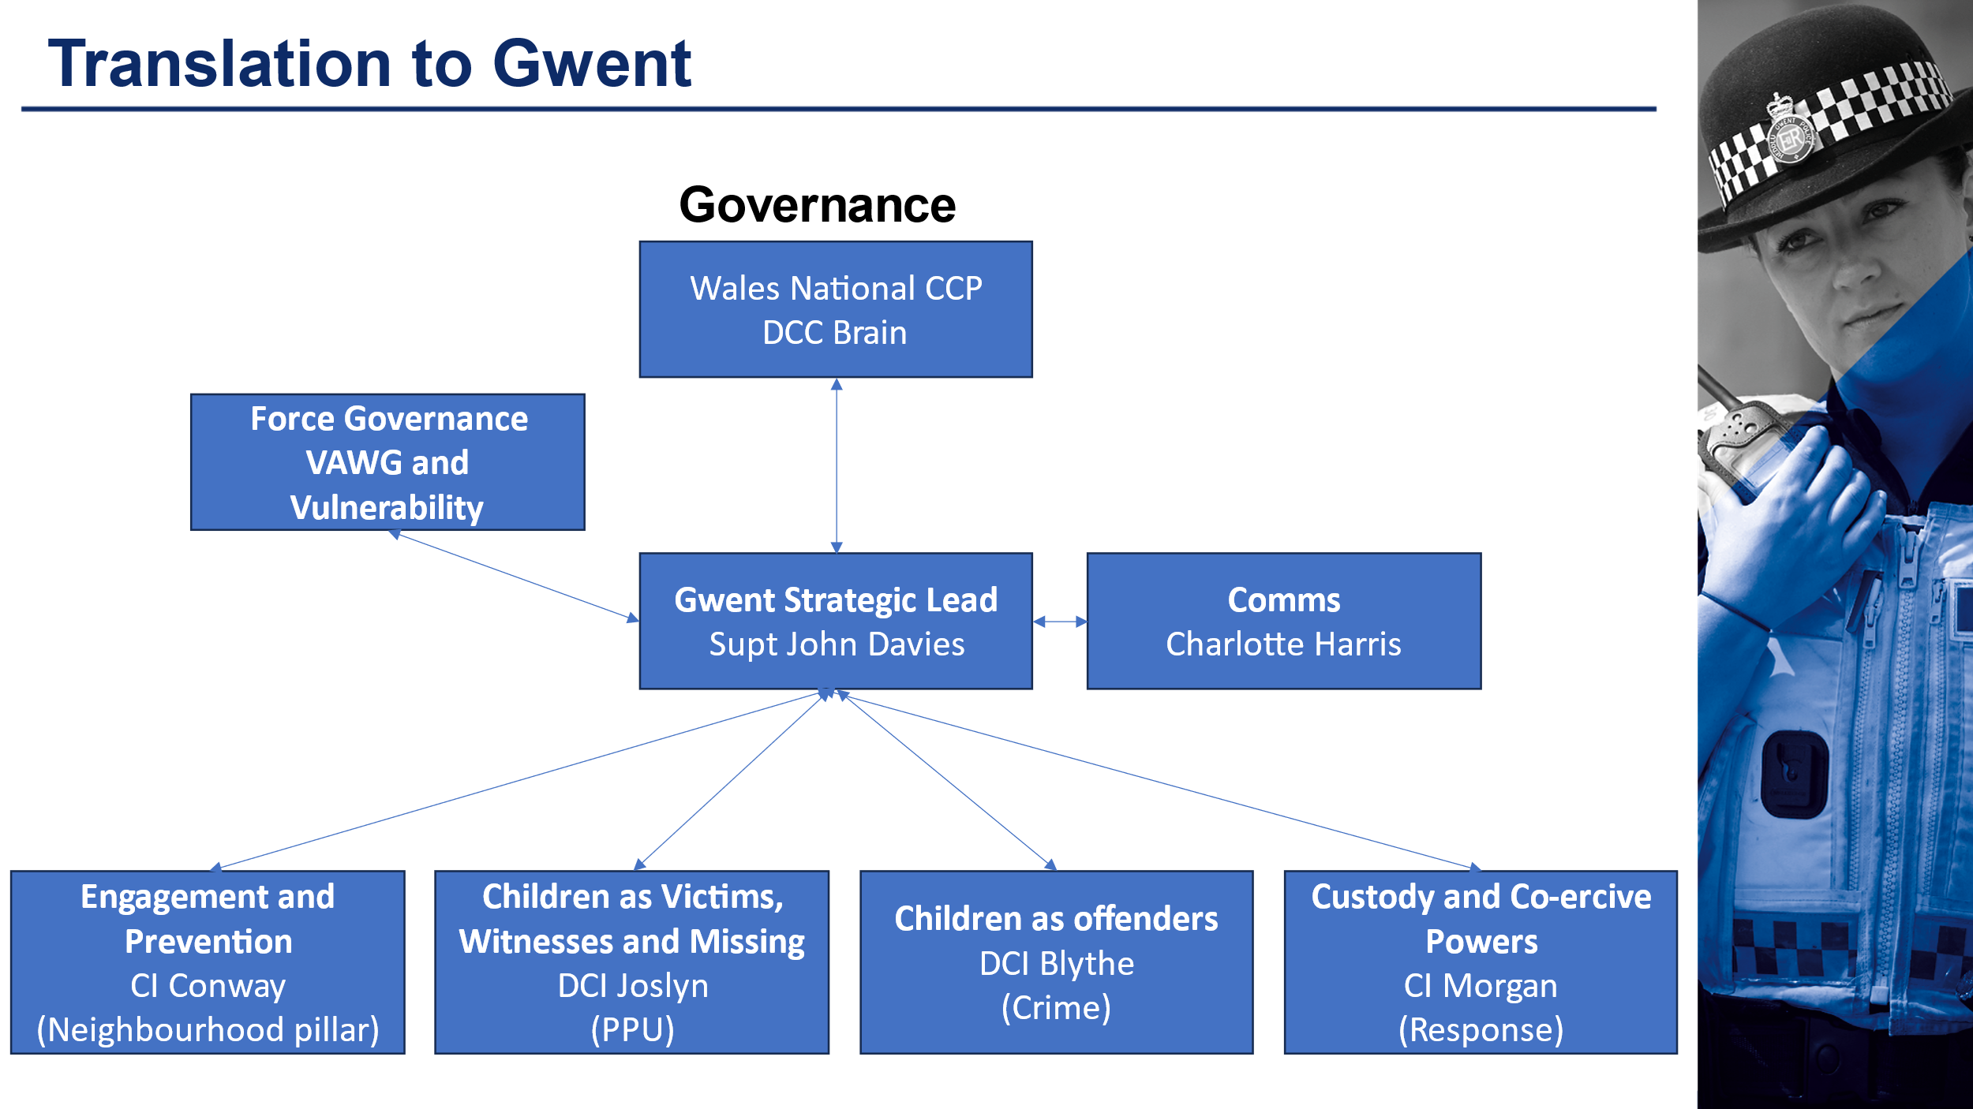
  - Given the cross-cutting nature of the CYP strategy across a number of workstreams. there will be a report into VAWG and Vulnerability and force governance will be managed through all Wales National CCP Leads Meeting Chaired by DCC Brain.
  - Engagement and prevention will cover all aspects on engagement with Children, to include Children’s AIG, Schools, and Heddlu Bach. As such this sits within the Neighbourhoods workstream.
  - Children as victims’ witnesses and missing, will be managed and reviewed with a view to improving the experiences of children in these areas
  - Children as offenders strand will continue to look for opportunities to avoid the criminalisation of young people providing them a future in line with the strategy.
  - Finally, custody and coercive powers will look to improve the experiences of children when dealt with directly by the police.
  - Although each strand will have a feed into the overarching Gwent Level Strategic board, much of the work associated with the strategy will be undertaken in other boards such as, Investigative standards. The tactical leads will ensure that the Strategy is considered in each of these governance areas.

- COLLABORATION

  - Collaboration will continue to be a focus. Working with partners particularly in Youth Justice, Social Services and Education will be essential to making improvements.

- NEXT STEPS

  - Next steps will be for each strand lead to put in place a performance framework which will monitor performance through each area. It is clear some of these metrics will be qualitative from the engagement lead. Qualitative feedback will be essential to understanding the lived experience of children in contact with policing.
  - Initial meetings have taken place with formal Structures commencing in March 2025.

- FINANCIAL CONSIDERATIONS

  - There are no current financial considerations or identified investment need.

- PERSONNEL CONSIDERATIONS

  - I am satisfied that this fits within the capacity and capability of those identified to progress this work.

- LEGAL CONSIDERATIONS

  - None Identified.

- EQUALITIES & HUMAN RIGHTS CONSIDERATIONS

  - This report has been considered against the general duty to promote equality, as stipulated under the Strategic Equality Plan and has been assessed not to discriminate against any particular group.

  - In preparing this report, consideration has been given to requirements of the Articles contained in the European Convention on Human Rights and the Human Rights Act 1998.

- RISK

  - There are no current risks to highlight in this paper.

- PUBLIC INTEREST

  - In producing this report, has consideration been given to ‘public confidence’? Yes

  - Are the contents of this report, observations and appendices necessary and suitable for the public domain? Yes

  - If you consider this report to be exempt from the public domain, please state the reasons:

  - Media, Stakeholder and Community Impacts:

- REPORT AUTHOR

  - Superintendent John Davies

- LEAD CHIEF OFFICER

  - DCC Brain

- ANNEXES

  - None

- GOVERNANCE BOARD AND CHIEF OFFICER APPROVAL

15.1 This report has been presented to the following Chief Officer Board:
Meeting chaired by: N/A

Meeting date: N/A

Actions and amendments arising from board:

15.2 This report has been presented to the Scrutiny Executive Board:

Meeting chaired by: N/A

Meeting date: N/A

Actions and amendments arising from meeting:

Any risks/issues identified:

15.3 I confirm this report has been discussed and approved at a formal Chief Officers’ meeting.

Meeting chaired by: CC Hobrough

Meeting date: 11.02.2025

I confirm this report is suitable for the public domain.

Signature:

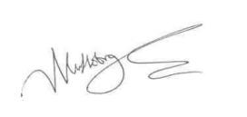
Date: 11.02.2025

