Title: | CTP Wales
Nature of paper: | Update for PCW Programme Board
Date: | May 2023
Responsible Officer:  Author(s): | Det Supt Emma Naughton  Noel Harris
Governance Meeting: | Police Collaboration Wales Programme Board
Version: | V1

- INTRODUCTION
The purpose of this report is to provide a summary of the resource position, trends, threats, matters for escalation and a snapshot of activity which has been delivered by CTP Wales. No changes have emerged to bring rise to concerns or challenges for the Unit.

- FINANCE
The CTP Wales CT grant funding is managed by SWP finance dept. on behalf of the CT network. There is currently no further update regarding CT finance since last board as year-end reporting has not yet been completed. Financial returns have been requested from all forces for year-end reporting and full financial report will be provided at next board meeting.

.

- ESTABLISHMENT
The total CTPW establishment at 1st May 2023 is 240.45 FTE including CT Borders and Special Branch staff/officers.

CTP Wales currently has 22 officer vacancies:

Force | Establishment | Strength | Vacancies | Post filled awaiting start date
Dyfed Powys | 25.5 | 23.35 | 3 | 0
Gwent | 20.5 | 19 | 1 | 0
North Wales | 41 | 37.85 | 3 | 0
South Wales | 77 | 61.8 | 15 | 3
Total | 164.5 | 147.5 | 16 | 3

Staffing ratios from Forces:

Force | Ratio
SWP | 57%
NWP | 21%
DPP | 13%
GWP | 9%

To be noted: The Strategic Efficiency & Reinvestment Review (SE&RR)

The SE&RR reductions were applied by CTP HQ from 1st April 2023. Discussions are ongoing with CTP Finance and HR to rebut a number of the reductions using compensatory savings from elsewhere in the CTP Wales establishment.

- PERFORMANCE

Pursue

Currently 11 live Priority Operations and 8 live leads being managed by CTP Wales (an additional 4 Operations are co-managed by CTP West Midlands).

Also (as at 03/05/2023):

- 51 sub-lead development enquiries being managed.
- 39 Closed Subjects of Interest (persons) currently being monitored, with trip wire coverage in place.
- 22 subjects adopted by the Nominal Management Team (including 17 Registered Terrorist Offenders and 6 offenders in HMP estate). Project ELEOS aims to combine Prevent and Nominal Management under Interventions capability by FY 24/25.
- 3 investigations with CPS for charging decision, 1 recent Voluntary interview, 1 awaiting trial, 2 new arrests.

Prevent

- A total of 110 referrals during the Q4 period (up from 74 in Q3, 39 in Q2). The corresponding period in 2022 saw 57 Prevent referrals.

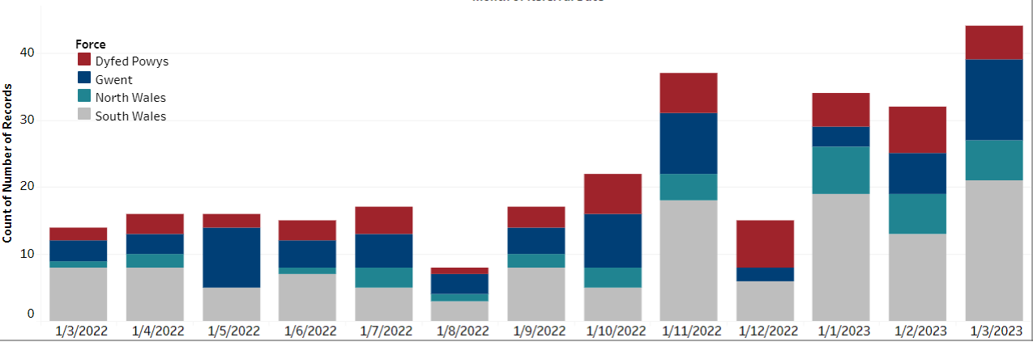

- The increase in referrals came largely from schools and non-CT policing, though there were also increases from social services, health, and family.

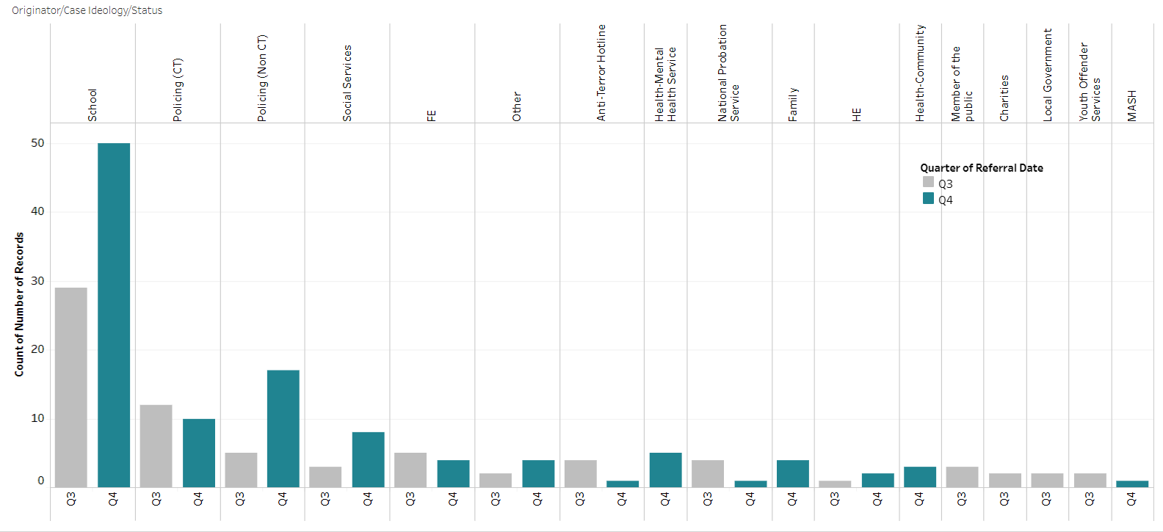

- No ideology or CT risk was determined in 49% of referrals (up from 30% in Q3), with a further 16% having Mixed/Unclear or unstable ideologies.

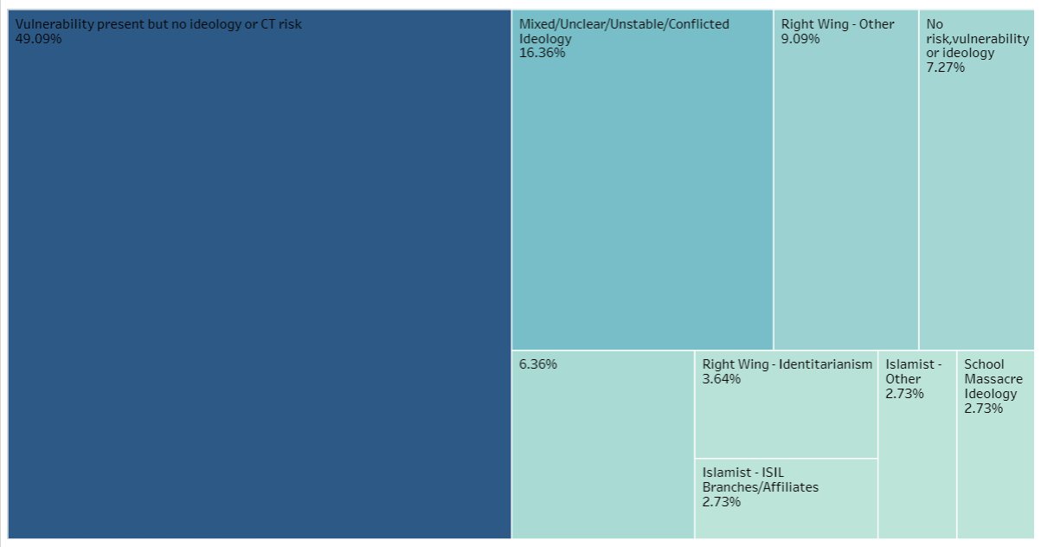

- As at 10/05/2023, there are 28 open cases, with 13 in Channel and 1 in police-led case management.

Prepare & Protect

The Prepare team are currently heavily committed building plans for a national CT exercise on behalf of UK CT policing, which is being hosted in Wales July 2023, whilst continuing to deliver a full testing and exercise schedule across the region. The events undertaken have reached many individuals including multi-agency Cat 1 Responders and Partners

The CTSA’s continue to work with Protective Security Preparedness Groups [PSPG’s] updating on current Protective Security projects and ensuring the role out and understanding of the draft Protect Duty (Martyn’s law) is consistent throughout Wales.

CTSA’s continue to have oversight of major events within the regions, linking in with Force planners and Event Safety Advisory Groups [ESAG’s] to ensure protective security measures are considered and proportionate.

Preparation is underway arranging the next ACT Corporate event. This follows the successful ACT Corporate event that took place in Cardiff on the 18^{th of} January 2023 that captured over 150 attendees from businesses and local authorities across Southern Wales. The next event will attract a larger audience across Wales by extending the invites via webinar.

It's anticipated that the CTP Wales capacity for Protective security advice will increase across the region as a further three CTSA’s will become occupationally competent by the end of 2023. In addition, a further two CTSA’s are due to attend a foundation course and commence the learning pathway to accreditation.

Borders CTP

The required efficiency savings identified by the BOM-R (Border Operating Model Review) of £384,825 has not yet been resolved. These savings are based on the non-CT activity predominantly at Holyhead port. ACC Harman (NPCC Maritime lead) will be taking this issue forward with NWP ACPO.

The accuracy of manifest data on the CTA routes continues to be problematic. The BOM-R have now identified this as a key priority to address, and CTP Wales has provided examples of poor data quality to support the resolution to this issue.

Passenger numbers on the CTA ferry routes remain constant. Holyhead has been awarded Freeport status, but this should not impact on CT Borders. Cardiff airport has reported that passenger numbers will remain static for the next financial year, however they are optimistic with new routes being announced by Air France/Eastern airways and Ryanair that passenger numbers are likely to increase.

- ESCALATIONS – DECISION NEEDED

None

-ENDS-

