ANNEX 1

Gwent SAR Performance up to and including March 2024.

Please see information below:

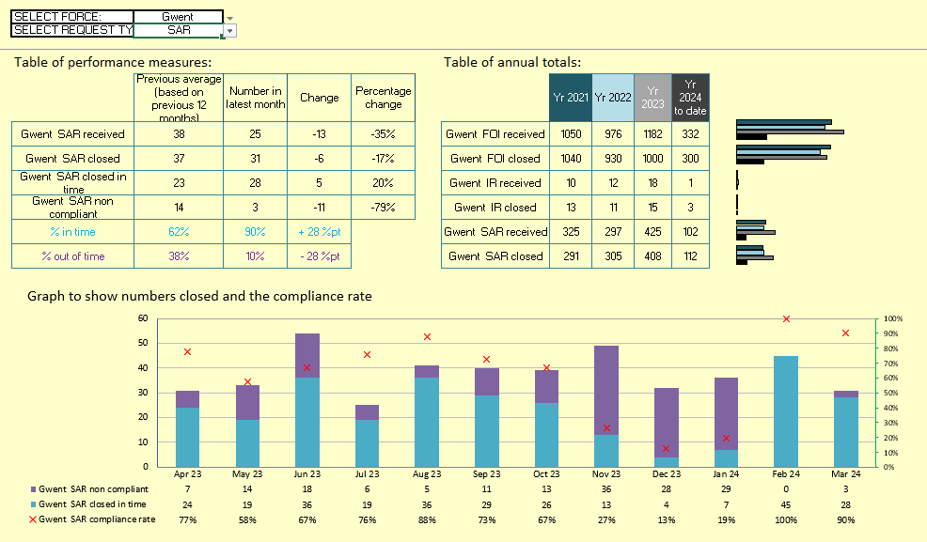
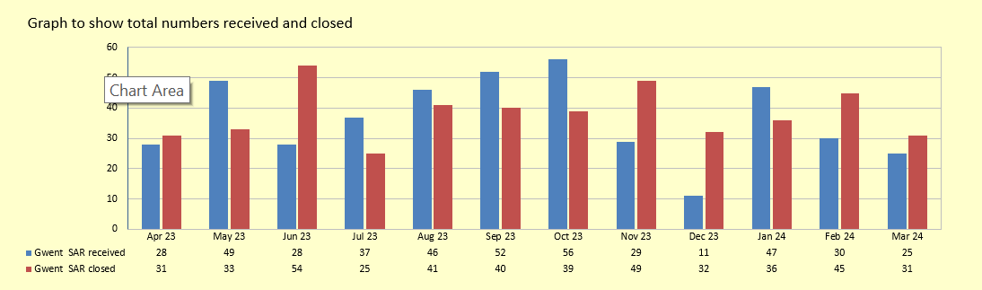

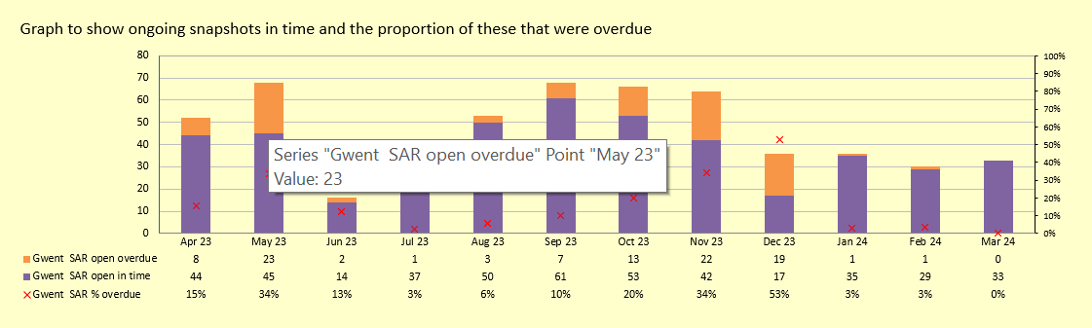

FOI Performance up to and including March 2024.

Please see information below:

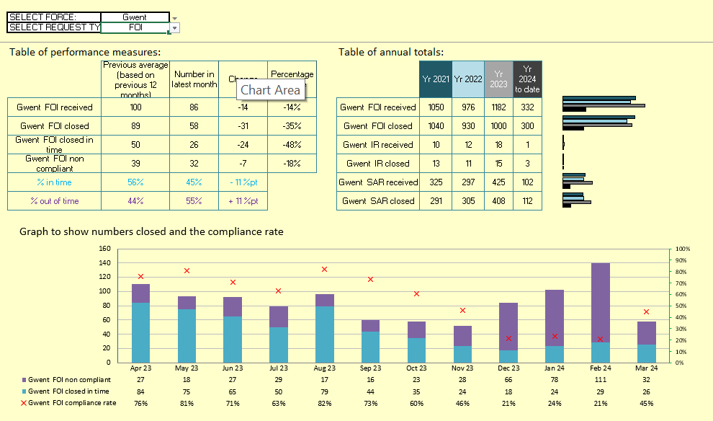

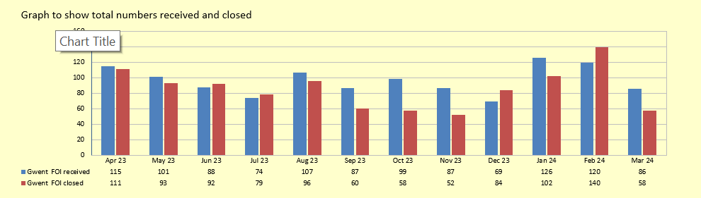

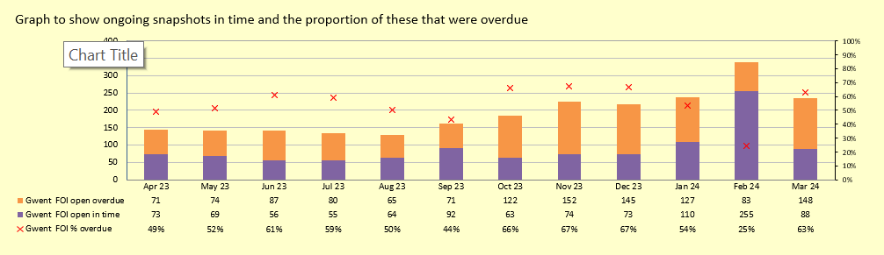

FOI (Internal Reviews) Performance up to and including March 2024.

Please see information below:

