|  |
| --- |
| Information Services |
|  |
| Annual Report  2024 - 25 |
| Joint Audit Committee |
| September 2025 |

1. ***DIBEN AC ARGYMHELLIAD* |** **PURPOSE AND RECOMMENDATION**
   1. The report presents the annual outturn on the delivery of Information Services in Gwent Police.
   2. There are no recommendations made requiring a decision
2. ***CYFLWYNIAD A CHEFNDIR* |** **INTRODUCTION & BACKGROUND**
   1. The Information Services Department is responsible for the provision of statutory and regulated functions, delivered across four core delivery areas:

* Firearms Licensing
* Disclosure & Barring Service (DBS)
* Data Protection disclosures
* Police National Computer Bureau

The department facilitates transactional services to the public and third-party organisations, to include:

• Subject rights - Subject Access Requests (SAR)

• Freedom of Information requests (FOI)

• Children & Family Court Advisory Support Service (CAFCASS)

• Criminal Injury Compensation Authority (CICA)

• Family Court Orders

• Data Protection requests

• Legal Aid

• Common Law Police Disclosures (CLPD)

• Local Authority Child Safeguarding checks

• Probation Service Domestic Abuse Intelligence Checks

* South Wales Adoption Service – Pre-Adopter Checks

• Road Traffic Collision (RTC) disclosures

• Disclosure and Barring Service (DBS)

• PNC / LEDs Updating

• Warrants Management

• Road Traffic Collision statistics for Welsh Government

• Firearms Licencing Unit (FLU)

2.2 In January 2024 a structural review of Information Services was initiated in recognition of the fact that the previous review was only partially completed under Phase 1, with Phase 2 being suspended on the basis that the demand profile and process maps no longer reflected demand practice. This created a disparity in pay grades which has necessitated honorarium payments.

2.3 The Business Case has addressed the disparity, together with proposals to improve efficiency and effectiveness of service provision. The Business Case was presented at Service Improvement Board in May, with Chief Officer sign off in June 2025. It is anticipated that full implementation will be achieved by October 2025.

**3. MATERION I’W HYSTYRIED | ISSUES FOR CONSIDERATION**

The reporting arrangements have been operational throughout the financial year. Performance throughout the financial year in key delivery areas is summarised below.

**3.1 Subject Access Requests (SAR)**

Principles set out within the Data Protection Act 2018 provide Individuals with the right to be informed about the collection and use of their personal data. Data Controllers must provide certain information, such as purposes of processing, retention periods, details of data processors. This information is set out within the Corporate Privacy Notice. Under a SAR application, individuals may request access to their personal data held by the force, which can include convictions, Niche occurrences, body worn video footage, custody interviews, 999 calls. This also extends to personal data held about employees or volunteers. SARs must be responded to within one month unless an extension is applicable.

Demand for SARs totalled 440 applications during the year. Compliance fluctuated throughout the period, ranging from 46% in May to 100% in August and throughout the remaining months in the period. The Force mean average for the year was 93%. The National average was 76%.

The below chart illustrates the annual performance for SAR:

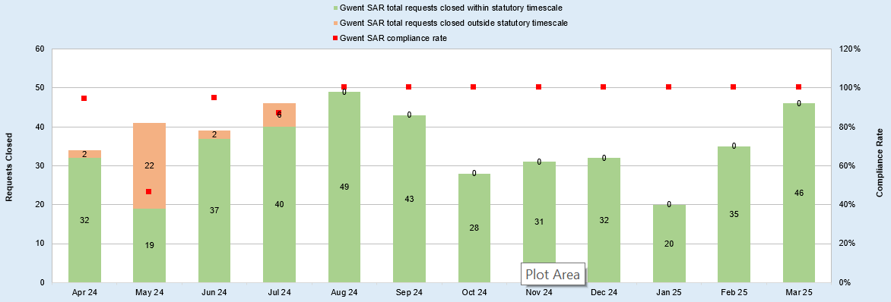

**3.2 Freedom of Information (FOI)**

The Freedom of Information Act 2000 grants the public the right to access information held by public authorities with a view to ensuring transparency and accountability in public services. The statutory compliance rate is 90% within 20 working days. An Improvement Plan was developed to address compliance in this area (see Annex 1). A strategic risk was raised in respect of FOI compliance, monitored via corporate governance. The risk was reduced to *Low* *impact* in November.

Demand for FOIs totalled 1,012 requests during the year. Monthly compliance for the year fluctuated from a low of 13% in April, steadily improving month on month with September recording 90% compliance, meeting the standard threshold. Compliance continued to improve thereafter, recording 100% in February. The Force average for the year was 80%, albeit from September until March, compliance exceeded the statutory 90%. The National average for all forces was 77%.

The below chart illustrates the annual performance for FOI:

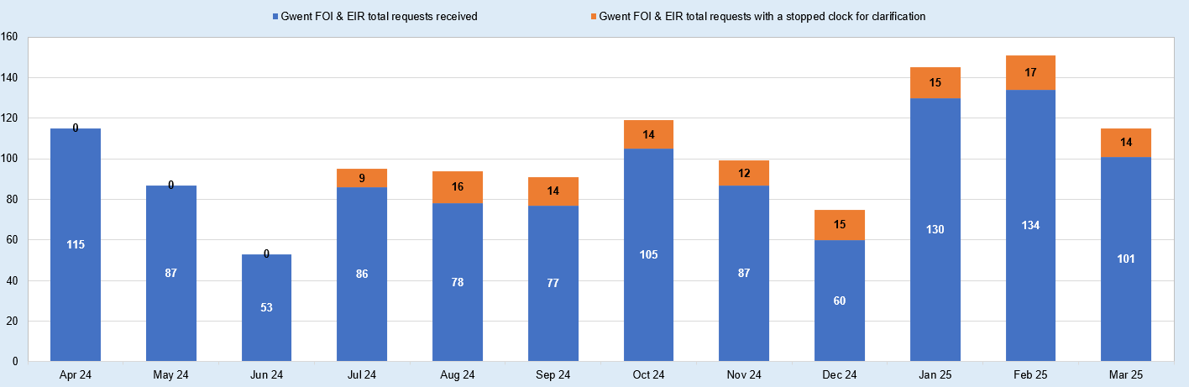

An internal audit of Disclosure, which included FOI, was conducted in 2023. The outcome resulted in *Limited Assurance.* Key findings relating to the FOI team were capacity and resourcing. The outcome of the aforementioned audit was reported via the Joint Audit Committee, together with the improvement plan, to provide assurance and scrutiny. No audit is currently scheduled for FOI.

The ICO FOI Self-Assessment Toolkit provides a mechanism for assessing a public authority’s current position in respect of FOI timeliness. This assessment was carried in January resulting in the overall rating of Good.

There were two factors that affected FOI performance: capacity within the FOI Team to process requests and capacity within business areas to provide responses. The FOI Team is now fully staffed, complimented with an additional temporary resource (1 x WTE) to support the function, approved until July 2025.

As a result of high-profile misconduct cases involving serving Police Officers, and Baroness Casey’s Report on Misconduct (Metropolitan Police Service), a national surge for FOI requests in relation to Police Misconduct was seen. This placed demand on both the FOI Team and the Professional Standards Department in terms of analytical capability.

The number of FOI requests that were overdue (>20 working days) during 2024 peaked at 147 requests in April. With Chief Officer oversight driving compliance, performance improved month on month, resulting in just one overdue request at the end of the reporting period. It is now standard practice that overdue FOIs are reported to Chief Officers through force governance. They receive schedules of overdue FOIs in each of their departments, which allows them to ensure timely responses are correctly prioritised.

Chart 3 illustrates the annual performance for overdue FOIs.

The FOI improvement plan was monitored through force governance, and included development of a performance dashboard, automation of processes and increased Chief Officer focus.

**Chart 3 – FOI Overdue Stats by Month**

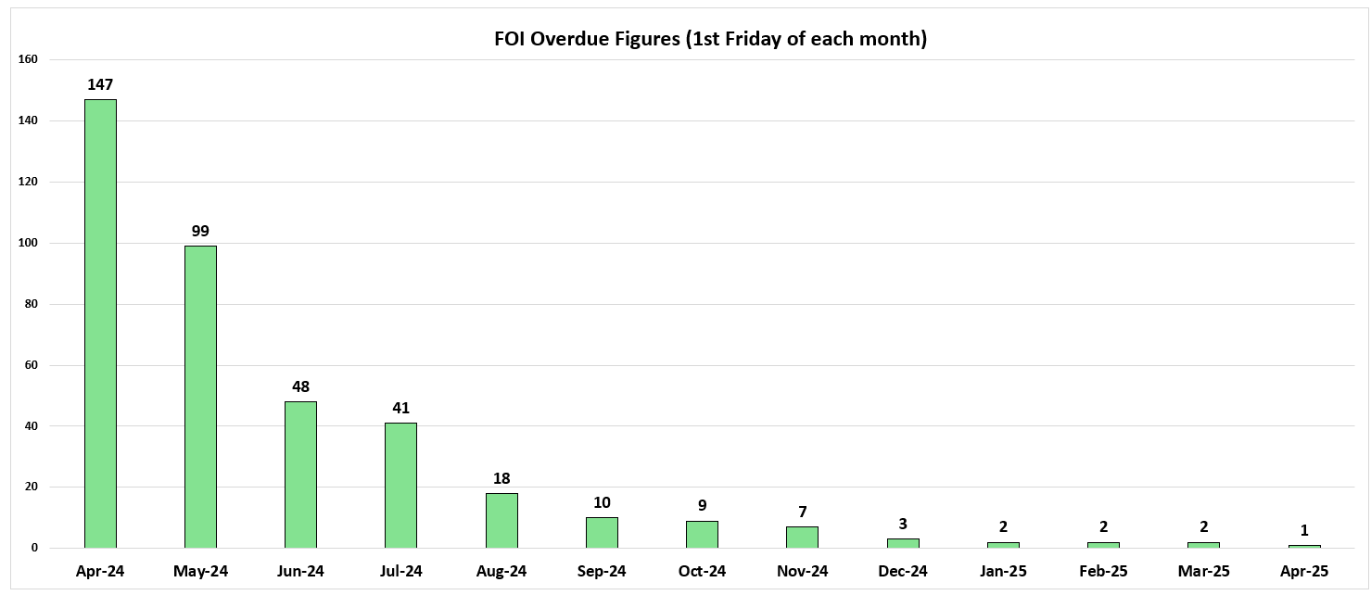

There is a requirement on all public authorities to make certain information available to the public, as mandated by the Information Commissioners Office. Previously disclosed FOIs are published on the Disclosure Log held with the Publication Scheme, available via the website at the following link: [Published items | Gwent Police](https://www.gwent.police.uk/foi-ai/af/accessing-information/published-items/?q=&dt=Disclosure+log,Environmental+information+regulation,Publication+scheme&fdte=&tdte=&ic=&dir=&bor=).

**3.3 Environmental Information Regulations (EIR)**

The EIR provides public access to environmental information held by public authorities. Public authorities must make environmental information available proactively, and members of the public are entitled to environmental information. There were nil requests in respect of the EIR during the reporting period.

**3.4 Children and Family Court Advisory and Support Service (CAFCASS)**

CAFCASS is an independent arbitration service representing children in Family Court. These include Public and Private Law cases. The function includes the provision of Police National Computer (PNC) review and also locally held Police information. Disclosure is required within 5,10 or 15 days depending upon the level of check required.

With effect from November 2023, CAFCASS Cymru centralised the PNC level checks which reduced the demand placed on the provision of data by the police.

There were 178 requests during the reporting period.

Performance recorded 100% compliance throughout the year.

**3.5 Road Traffic Collision Disclosures (RTC)**

Requests fall into three categories:

* Motor Insurance Bureau (MIB) - disclosures for untraced drivers.
* Association of British Insurers (ABI) - validating insurance claims.
* 3rd Party requests – Insurers registered with the ABI.

There are key performance indicators for MIB requests (20 working days) and ABI (30 working days) requests, all other requests are dealt with subject to demand and capacity. 3rd Party requests is a high demand area and there are mechanisms in place to ensure performance is monitored.

In April 2024, there was a backlog of 3rd Party requests (approx. 600). This accrual was owing to demand exceeding capacity within the disclosure team. A local plan aimed at reducing the backlog was implemented, resulting in the backlog being removed by December. There were 778 new requests during the reporting period. Performance recorded 100% since January.

MIB requests totalled 103 during the reporting period. Performance recorded 100% compliance throughout the year.

ABI requests totalled 51 during the reporting period. Performance recorded 100% compliance throughout the year.

**3.6 Criminal Injuries Compensation Authority (CICA)**

The Criminal Injuries Compensation Act 2003 provides victims of violent crimes the right to make a claim for compensation.

This involves the processing of requests and provision of information of police held information to CICA, who handle requests on behalf of injured parties.

There were 956 recorded requests during the reporting period.

Performance recorded 100% compliance throughout the year.

**3.7 Family Court Disclosure**

The Disclosure of Information between Family and Criminal Agencies and Jurisdictions: 2024 Protocol came into effect on 1 March 2024. It replaced the 2013 Protocol and Good Practice Model: disclosure of information in cases of alleged child abuse and care directions hearings.

This involves the provision of Police held information as detailed in the Court Order, relating to Private and Public Law matters. There was a reduction in Local Authority Court Orders in 2024, compared to 2023 of 14% which may be attributable to the revised protocol.

The national protocol states that responses to requests for information or material should be provided as soon as reasonably practicable and within 20 working days, or as specified by the Court Order. The local performance measure is 10 working days in which to disclose.

There were 57 Orders received for Private Law, and 540 Orders received from the Local Authorities, during the period.

Performance recorded 100% compliance throughout the year.

**3.8 Data Protection Disclosure Requests**

This involves the disclosure of information within the parameters of the Data Protection Act 2018 and the General Data Protection Regulations. There is no specified timescale to respond to these requests.

There were 453 recorded requests during the reporting period.

**3.9 Common Law Police Disclosures (CLPD)**

The CLPD provisions relate to the circumstances in which the police use common law powers to disclose police information regarding an individual in order to enable a third party (employer/regulator) to consider risk mitigation measures in respect of an employment or voluntary role believed to be undertaken by that individual. There is no statutory timescale but a local target of 72 hrs in which to disclose.

There were 873 recorded requests during the reporting period.

Performance was above 95% Apr – Aug inclusive, and 100% for the remainder of the year.

**3.10 Safeguarding Checks**

Section 44 of the Children Act 1989 provide Local Authorities the legal right to remove a child from accommodation or prevent removal, where they have reasonable cause to believe the child would otherwise be likely to suffer significant harm. Relevant person and address checks are conducted with police to assess risk. There is no statutory timescale but a local target of 10 working days in which to disclose is set, unless the request is marked urgent.

There were 2,046 requests during the reporting period.

Performance recorded 100% compliance throughout the year.

**3.11 Probation Service Domestic Abuse Checks**

The Probation Service is required to undertake domestic abuse checks as part of pre-sentencing reports and the Government Early Release Scheme for prisoners serving 40% of their sentence. Relevant person and address checks are conducted with police to assess risk. There is no statutory timescale but a local target of 10 working days in which to disclose is set, unless the request is marked urgent.

There were 3,130 requests received during the reporting period.

Performance recorded 100% compliance throughout the year.

**3.12 Disclosure Barring Service (DBS)**

The DBS Unit is responsible for conducting enhanced DBS checks against potential matches sent by the DBS Agency for nominals applying to work in regulated activity. Activity includes Barring referrals, handling disputes and conducting identification fingerprints.

In the reporting period, incoming demand totalled 37,055 enhanced disclosure checks. This demand averaged 9% above forecast demand.

DBS requests demand has risen year on year. This is attributable to the mechanism for the PLX upload (locally held information submitted to DBS Agency). Activity has been initiated with SRS to review the PLX Upload so that only those records that indicate a change since the last upload are submitted, as opposed to an overwrite of all relevant nominals, thereby reducing the demand placed on the DBS Unit. The forecast demand for 25/26 is 43,000, based on current method of work.

Performance is measured in terms of timeliness and productivity based on the previous 4 weeks activity. The service standard for the number of checks closed within 15 days is 65% of workload. The force performance for the reporting period was 63.6%. This slight reduction in performance is directly associated with reduced capacity due to staff vacancies and abstraction rate. Performance in all other areas of timeliness and productivity remain within target threshold.

The Standards & Compliance Unit (SCU) within DBS manage performance in respect of compliance against the Quality Assurance Framework, for both Disclosure and Barring elements of demand.

In April 2024, the SCU grading for the Disclosure element was *Inadequate*. This was based on the DBS weighting assessed against the two previous years where a *Requires Improvement* grading was applied. An improvement plan was implemented in respect of performance in this area; strategic priorities focusing on Chief Officer oversight, upskilling key staff and performance monitoring. A mid-year grading (October) was conducted by SCU which resulted in a *Good* grading. This was confirmed at the end-of-year grading in April 2025.

The SCU grading for the Barring element was graded *Good* for the reporting period.

Chart 4 illustrates force performance against the timeliness measures set by the DBS Agency and details the SCU grading outcomes.

**Chart 4 DBS Balance Scorecard**

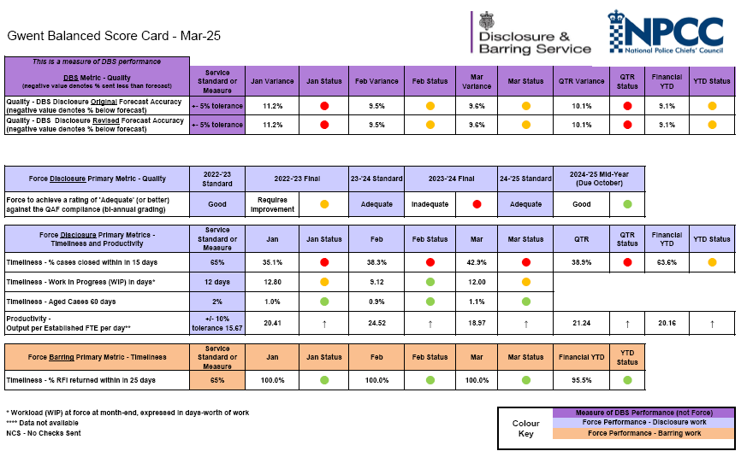

Under section 117A of the Policing Act, the Independent Monitor has a role to consider those cases within which a person believes that the information disclosed by police within a Disclosure and Barring Service Enhanced Criminal Records Certificate is either not relevant to the workforce they are applying for, or that it ought not be disclosed. During the review period, there were two cases reviewed by the Independent Monitor, both of which upheld the force’s decision to disclose information.

**3.13 Police National Computer Bureau (PNCB)**

The PNCB team maintain PNC Name and Vehicle updates including entering new records, managing alerts, updating current records and deleting records upon request, court resulting, impending prosecutions, and warrants administration. The team is also responsible for inputting Road Traffic Collision injury reports onto the mapping service (ACCSMAP) and the provision of RTC statistics to Welsh Government, to inform traffic management initiatives.

Implementation of the law enforcement database continues to be rolled out on a modular basis. Full impact on PNC Bureau is expected from September 2025 when it is anticipated that PNC will be decommissioned.

Performance in respect of Arrest Summons Creation averaged 89.9%. The target is 90% within 24hrs. The National average was 84.4%.

Performance in respect of Disposal History updates averaged 58.3%. The target is 75% within 10 days. The National average was 81%.

**3.14 Firearms Licensing**

Firearms Licensing is responsible for the management of applications (firearm, shotgun, explosives) and associated transactions, for residents of Gwent. The unit also reviews the certification of Registered Firearms Dealers and Shooting Clubs within Gwent.

There is a separate Annual Report for Firearms Licensing. For the purposes of this report, the following items are noted.

Firearms Licensing renewal demand increased notably from September 2024 into 2025 in line with the cyclical renewal process. 2025 sees an increase in renewal demand to 1,618 and a slow downward trend for the remainder of the next two to three years before seeing a peak again.

Firearms Licensing grants (new applications) incurred processing delays of up to 18 months during the year. This is owing to an accrual of grants, and the need to safeguard the public; prioritisation is given to those in possession of weapons (renewals). Performance in this area has improved, with grants now taking approximately 10 months from application to issuance of certificate.

The Home Office outlined the government’s intention to introduce a statutory instrument to raise fees to achieve full-cost recovery for police forces. This was approved in early 2025 and will result in a significant increase of income generation. Currently, the cost of operating the FL team outweighs the income received from FL certificate holders and is therefore subsidised by the taxpayer. The annual income generation for firearms licensing activity was £62,777 in 2024. This is forecast to rise to £145,480 in 2025 to the increased demand attributable to the cyclical renewal and more notably, the proposed increase in fees outlined by the current Minister of State for Policing, Fire and Crime Prevention on 15th January 2025.

**3.15 Unpredicted Demand**

Probation Service reportable incidents disclosures were temporarily diverted from the Probation Service, via direct access to Niche, and managed by the Disclosure Team. This was because of data security concerns relating to external access to data. This unpredicted demand created greater pressure on the team and exceeded capacity thresholds over a four-week period, totalling 433 requests.

***4. CYDWEITHIO* | COLLABORATION**

As documented throughout the report.

**5. CAMAU NESAF | NEXT STEPS**

1. 5.1 The force will continue to report performance for all areas within Information Services via the Information Assurance Board.
2. 5.2 A departmental review was initiated in January 2024, encompassing all functions within Information Services. The Service Improvement Board approved the Business Case in May 2025, with implementation commencing after FCOT sign off in June 2025.
3. 5.3 Robotic Processing Automation (RPA) is being explored within all areas of Information Services, to alleviate demand through automation of high volume, repetitive tasks.  A scoping exercise is underway with the Digital Services Division to include process mapping to identify opportunities.
4. 5.4 FOI automation utilising MS Forms and MS Lists has been developed. Implementation is anticipated in Q2 2025 as it is dependent upon modification to the Single Online Home Portal, owned by the MPS.
5. 5.5 DocDefender (Riven) redaction software has been rolled out across the force and is the primary redaction method within Information Services. Riven estimate 80% efficiency savings however a conversative 40% has been estimated as part of the departmental review. Early indications suggest that the efficiencies gained, compared to AdobePro, are marginal. The Post Implementation Review (2026) will re-assess process efficiencies in this area.
6. 5.6 The ability to redact media files for disclosure under the Subject Access Provisions is impacted by technical barriers. Developments within NICE Investigate technology include the ability to track an object/image, enabling an operator to easily identify and redact images in a single transaction. The release of this version is expected under version R2.3. The upgrade to R2.3 was implemented by Digital Services Division in February 2025; however, this version does not yet incorporate Object Tracing as this feature is still subject to DSD testing. It is anticipated that this implementation will be completed by quarter 2 of 25/26.
7. 5.7 Co-pilot licences have been granted to a cohort within the senior management team, enhancing productivity with efficiency in the production of meeting notes, task management, and creating better communication and collaboration between colleagues.
8. 5.8 The PNCB spend a disproportionate amount of time obtaining RTC reports from Officers, manually inputting data onto ACCSMAP and uploading data to the Welsh Government interface. A proof-of-concept exercise was undertaken in respect of the data capture by Officers. This involved the conversion to MS Forms however the data parameters required for RTC reporting exceeded the permitted threshold for MS Forms, therefore the PDF form remains in place. DSD is developing technology within iPatrol to enable real-time single input of RTC reports, interfaced with CRASH, which will streamline the process, improve quality and remove administration by the PNCB.
9. 5.8 The Department for Transport introduced new requirements for road traffic collision injury reporting from January 2024. An updated version of ACCSMAP is available however this is reliant upon modification for the data capture, which will be addressed in the aforementioned DSD roadside capture. The ability to provide accurate data to the Welsh Government on road traffic collisions has been impeded by technical barriers. Gwent does not have a comprehensive street junction gazetteer on Niche, which is reliant upon the release of Ordnance Survey junction data (expected Q1 2024/2025). The long-term plan is that we will adopt the Home Office RTC reporting system CRASH.

**6. YSTYRIAETHAU ARIANNOL |** **FINANCIAL CONSIDERATIONS**

6.1 The revised orgnisational strucutre has been agreed and saw additional investment in the team during 2024/25.

6.2 Transition of RTC reporting over to CRASH will negate the need for ACCSMAP and the associated software licensing and support costs.

**7. YSTYRIAETHAU PERSONEL |** **PERSONNEL CONSIDERATIONS**

7.1 Training and support are provided to staff to ensure they are able to meet the obligations of their role.

7.2 Staff impacted by the departmental restructure will be appropriately supported in line with the Organisation Change Procedure.

**8. YSTYRIAETHAU CYFREITHIOL | LEGAL CONSIDERATIONS**

8.1 There are no legal implications at this stage.

**9. YSTYRIAETHAU CYDRADDOLDEB A HAWLIAU DYNOL |** **EQUALITIES AND HUMAN RIGHTS CONSIDERATIONS**

9.1 This project/proposal has been considered against the general duty to promote equality, as stipulated under the Single Equality Scheme and has been assessed not to discriminate against any particular group.

9.2 In preparing this report, consideration has been given to requirements of the Articles contained in the European Convention on Human Rights and the Human Rights Act 1998.

**10. RISG | RISK**

10.1 A Strategic Risk was raised during the course of this reporting period in respect of the FOI Compliance. The risk has since been mitigated and duly removed.

**11. BUDD Y CYHOEDD |** **PUBLIC INTEREST**

11.1 In producing this report, has consideration been given to ‘public confidence’? **Yes**

11.2 Are the contents of this report, observations and appendices necessary and suitable for the public domain? **Yes**

11.3 If you consider this report to be exempt from the public domain, please state the reasons:

11.4 Media, Stakeholder and Community Impacts: **None**

**12. AWDUR YR ADRODDIAD |** **REPORT AUTHOR**

12.1 Natasha Gilbert, Head of Information Services

**13. PRIF SWYDDOG ARWEINIOL |** **LEAD CHIEF OFFICER**

13.1 ACC Nick McLain

**14. ATODIADAU |** **ANNEXES**

None applicable

15. CYMERADWYAETH *LLYWODRAETHU A* BRIF SWYDDOG | GOVERNANCE BOARD AND CHIEF OFFICER APPROVAL

15.1 This report has been presented to the following oversight board: Organisational Resources Board

Meeting chaired by: ACC McLain

Meeting date: 24/07/2025

Actions or amendments arising from meeting: None

This report has been presented to the **Scrutiny Executive Board**

Meeting chaired by: **DCC Nicola Brain**

Meeting date: **5 August 2025**

Actions or amendments arising from meeting: **None**

15.2 I confirm this report has been discussed and approved at a formal Chief Officers’ meeting.

15.3 I confirm this report is not suitable for the public domain for the reasons stated in 11.3.

Signature: Date: