|  |
| --- |
| Stop & Search/Use of Force Report |
|  |
| Annual Report |
| 2023 | 2024 |

1. **PURPOSE AND RECOMMENDATION**

The purpose of this annual report is to provide a transparent view of the use of stop and search and use of force powers in Gwent over the last 12 months from April 2023 to March 2024. It will explain what Gwent Police is doing to improve the service it provides and ensure police powers are used effectively, legally, and proportionately.

1. **INTRODUCTION & BACKGROUND**

The use of stop and search is hugely important for protecting the public, tackling crime, and keeping our streets safe. Gwent Police understands that there is both a national and local impact of the use of stop and search on communities and individuals. The transparent and fair use of powers is a key element of maintaining public confidence. The main reason we use stop and search is to allow officers to investigate their suspicions about an individual without having to arrest them. How effective stop and search is, is as much about avoiding unnecessary arrests as it is about a crime being detected. We believe a stop and search is most likely to be fair and effective when:

1. the search is justified, lawful and stands up to public scrutiny.

2. the officer has genuine and objective reasonable suspicion they will find a prohibited article or item for use in crime.

3. the person understands why they have been searched and feels they have been treated fairly and with respect.

4. the search was necessary and was the most proportionate method the police officer could use to establish whether the person has such an item.

We welcome scrutiny and will continue to work with our communities and stakeholders to improve the quality of interactions and ensure that stop and search continues to protect the public.

**3. INTERNAL SCRUTINY AND ACCOUNTABILITY**

Following the COVID pandemic and the reduction nationally and locally of the use of stop and search the force continues to place significant focus on the use of appropriate, ethical, and proportionate stop searches with a slight increase in its use during 2023/24. Legitimacy still remains a clear priority for Gwent Police. The sub sections which follow highlight the monitoring and scrutiny we have in place.

**Operational Performance Board**

Monthly meeting chaired by the Assistant Chief Constable, where data about the use of stop and search and use of force powers are presented. There is a specific focus on disproportionality with the use of Police powers.

**Coercive Powers Scrutiny Meeting**

Chaired by the portfolio lead, meets quarterly and actively seeks to identify information which could suggest any abuse in the use of powers or discriminatory behaviour. The group was formed in 2020 and consists of a cross section of senior police managers, training and equality and diversity officers who provide internal oversight and scrutiny on the use of coercive powers to include stop search, more thorough searches which involve the exposure of intimate parts of the body, use of Taser and use of force. The group reviews stop search and use of force data from the most recent period carrying out careful analysis to determine any concerning trends or patterns, unacceptable use, learning opportunities, matters of policy and the examination of disproportionality.

**Local Policing Area (LPA) Scrutiny**

Both geographical policing areas (East and West) hold monthly performance and scrutiny meetings. Stop and search and use of force forms part of the LPA strategic performance review, and scrutiny at this level includes reviewing:

• Disproportionality and trends and comparative data across areas.

•Find rates across teams, including disparity and volume and trends by individual

officers.

• Activity alignment to local and force priorities.

• Individuals subjected to repeat stops.

• lawfulness of grounds recorded.

Supervisors of officers conducting stop and searches also have a responsibility to check the quality of grounds recorded on all stop and search forms and to ensure activity is proportionate. They also view body worn video records and, if necessary, take steps to address improvement such as further training or supervisory action.

**Coercive Powers Quality Improvement Group**

A tactical group, chaired by an Inspector which supports the Coercive Powers Scrutiny meeting and has nominated representatives from around the force responsible for:

• Dip sampling of all stop search and use of force records and officers Body Worn

Video.

• Training and development.

• National and best practice and scanning

**4. TRANSPARENCY AND EXTERNAL GOVERNANCE**

**Body Worn Video**

Gwent Police has issued personal Body-worn video cameras (BWV) to all of our frontline officers and staff and there is an expectation that recording is activated whenever coercive powers are used or when attending incidents likely to involve confrontation. The force reviews the footage from such incidents both internally and via the showing of randomly selected footage to the external independent Legitimacy and Scrutiny Panel.

**Legitimacy Scrutiny Panel**

This meeting is chaired by the Office of Police and Crime Commissioner (OPCC) and is held on a quarterly basis. Member of the panel include OPCC, Police, Independent Advisory Group (IAG) and Youth Offending Service. The panel provide feedback to the Police and Crime Commissioner (PCC) and to Gwent Police on the use of Police powers regarding stop and search and use of force. The Legitimacy Scrutiny Panel review records and video footage including stop and search, Taser use and other use of force. The panel provide feedback to Gwent Police on any identified training or development gaps.

**Training:**

We have invested in training all of our frontline officers and providing practical guidance in line with the College of Policing Authorised Professional Practice (APP) for using powers to stop and search. Training is provided through the completion of online material but reinforced with ongoing personal briefings to Sergeants during force training days.

**Multi Agency Task & Finish Group**

This group was implemented as a result of scrutiny from the Children’s Commissioner around the searching of children, specifically those searches with resulted in the exposure of intimate parts of the body (EIP). The group consisted of representative from all agencies that are part of the Local Safeguarding Board (LSB), and recommendations were made to the LSB to ensure additional scrutiny by partners was undertaken.

**5. STOP AND SEARCH DATA**

**Summary:**

* Total Stops increased in 2023/24 over the previous year by 10.5%.
* During 2023/24, stops conducted in the Newport area accounted for 41.4% of the

force total.

* 48.46% of all stops were conducted under S23 Drugs Act, a number which is lower than in previous years.
* The largest proportion of people Stop Searched continues to be aged between 18 and 25 (27.5%).
* The number of ethnic heritage stops as a percentage of total stops was 10.4%

with the largest proportions in Newport West. The ethnic heritage

population of Gwent is 8.6%.

* The overall Race Disproportionately Rate (RDR) was 1.6 meaning the ethnic

heritage population in Gwent were 1.6 times to be stopped more than the white population.

* The find rate for the Force as a whole was 24.8%. This figure was highest in Caerphilly Central which had a find rate of 32.5%.
* The use of Body Worn Video (BWV) for stop and search was 94.5%.

**Total Stop Search Numbers**

|  |  |  |  |
| --- | --- | --- | --- |
|  | **22/23** | **23/24** | **PP Diff** |
| **Person Stops** | 2227 | 2472 | 11.0% |
| **Vehicle Stops** | 479 | 518 | 8.1% |
| **Total** | **2706** | **2990** | **10.5%** |

The table and chart above highlights that overall stops have risen between 2022/2023 and 2023/2024 by 10.5%. However, the number of searches carried out are still not at the level prior to the Covid pandemic. The Covid pandemic allowed for policing to reset and focus more on the quality of the stop and search and proportionality.

|  |  |  |  |  |
| --- | --- | --- | --- | --- |
| **Total Stops Legal Power Used - 23/24** | | | | |
|  | **East LPA** | **West LPA** | **Other** | **Total** |
| **S1 PACE 1984** | 594 | 538 | 123 | **1255** |
| **S139B CJA 1988** | 0 | 0 | 0 | **0** |
| **S23 Drugs 1971** | 837 | 625 | 159 | **1621** |
| **S47 Firearms 1968** | 26 | 21 | 7 | **54** |
| **S6(3) PACE 1984** | 5 | 0 | 0 | **5** |
| **Not Recorded** | 8 | 8 | 35 | **51** |
| **Other Statutory Power** | 0 | 1 | 3 | **4** |
| **Total** | **1470** | **1193** | **327** | **2990** |

The above table shows that ‘S23 Misuse of Drugs Act 1971’ continues to be the most used power for stopping people, accounting for 48.46% of total Stop Searches carried out. The question of why so many searches are carried out using this power is one that comes up frequently. Many of the searches carried out for drugs are in relation to cannabis and are the result of the “reasonable grounds to suspect” being formed, in part, due to the distinctive smell of the drug. In many of these cases there was no prior intent by the officer to conduct a search but having stopped a vehicle for example and having smelled cannabis, additional factors become apparent, such as openly visible drugs paraphernalia. They then conduct a search to confirm or allay their suspicions. (N.B. It is important to point out that officers cannot conduct a drugs search on the grounds of smell of cannabis alone).

|  |  |  |
| --- | --- | --- |
| **Total Person Stops by Section - 23/24** | | |
| **Section** | **Total Person Stops** | **% of Total Stops** |
| Blaenau Gwent | 218 | **8.8%** |
| Caerphilly Central | 154 | **6.2%** |
| Caerphilly North | 153 | **6.2%** |
| Caerphilly South | 120 | **4.9%** |
| Monmouthshire | 245 | **9.9%** |
| Newport City Centre | 196 | **7.9%** |
| Newport East | 323 | **13.1%** |
| Newport West | 504 | **20.4%** |
| Torfaen | 337 | **13.6%** |
| Outside Force | 49 | **2.0%** |
| No Location | 173 | **7.0%** |
| **Total** | **2472** |  |

The above table shows all Person Stops by section where a known location is recorded. As can be seen, Newport accounted for 41.4% (n=1023) of all stops conducted within the Force area, which is an increase from 2022/2023 where 35.7% of all stops were conducted in Newport.

The table below illustrates the ages of those stopped in each section during 2023/24. It shows the largest proportion of people Stop Searched continues to be aged between 18 and 25 (27.5%; 642). The number of under 17s being stopped accounted for 25.4%; something which is monitored closely at all scrutiny meetings.



The below table shows the wards where the most Person Stops have occurred. The number of stops these top five wards accounted for has increased slightly, from 27.7% in 2022/23, to 30.4% in 2023/24. It means that just under a third of all stops around the force occurred within just 5 wards.



**Ethnic Heritage Searches**



As can be seen in the table above the highest numbers of ethnic heritage searches occurred within Newport West (n=83) with a total of 182 occurring across the whole city of Newport.

75 ethnic heritage searches took place in all other locations around the force. This meant the overall force ratio of ethnic heritage individuals stopped was 10.4%, a reduction from 2022/2023 of 13.5%.



Above is the breakdown of Ethnic Heritage Stops and White Stops by section, providing the RDR (Race Disproportionality Rating) for each. It shows that overall, the Force has a RDR of 1.6 for the year. This means that a person from the ethnic heritage community was 1.6 times more likely to be Stop Searched in Gwent during 2023/24 than someone from a white background. This is a decrease from 2022/2023 where the RDR rate was 2.0.

**Find Rates**



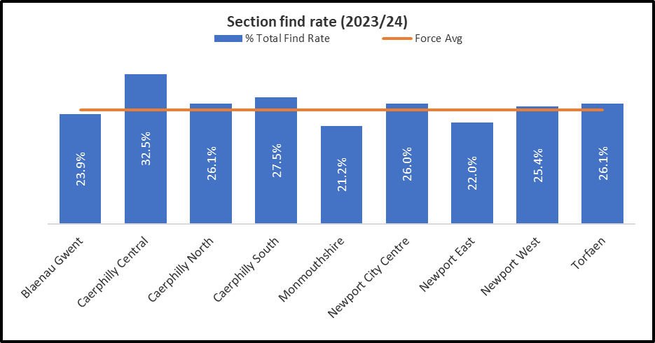

The above Table and Chart highlight the find rates for all Stops carried out during 2023/2024 and indicates that overall, on 24.8% of occasions the item searched for was recovered. This is a decrease on the previous year’s data where the find rate was 26%.

**Body Worn Video**



As can be seen in the above table, BWV compliance during 2023/24 force wide was 94.5%. The small number of instances where BWV was not used, camera out of power was the most prevalent reason (2.1%; n=52).

**Exposure of Intimate Parts searches (EIP)**

These searches were formally known as Strip Searches and the language has been changed recently to consider the sensitivities aligned to the previous term. The force closely monitors the number of EIP searches of children. In 2023/2024 there were 3 EIP searches recorded of a child under 18 years.

**6. USE OF FORCE DATA**

## 

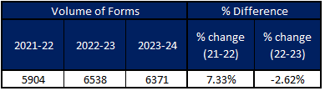

The above tables show that in 2023/2024 there were a total of 6371 use of force forms submitted, a decrease of 2.62% (n=167 forms) compared to 2022/2023 (6538 forms). This data is closely monitored at internal governance meetings.

In the below table, of the 6371 use of force forms submitted in 2023/2024, 5762 (90.4%) stated that the subject was of White ethnicity and 579 (9.1%) forms stated the subject was from an Ethnic Heritage group. Currently all ethnicity data relating to use of force is based on Officer perceived ethnicity. In terms of the forms submitted, some individuals may be counted more than once. This is because each Officer who uses force must submit a form to state their involvement, and on some occasions multiple Officers will be required to use force on the same person in the same incident.

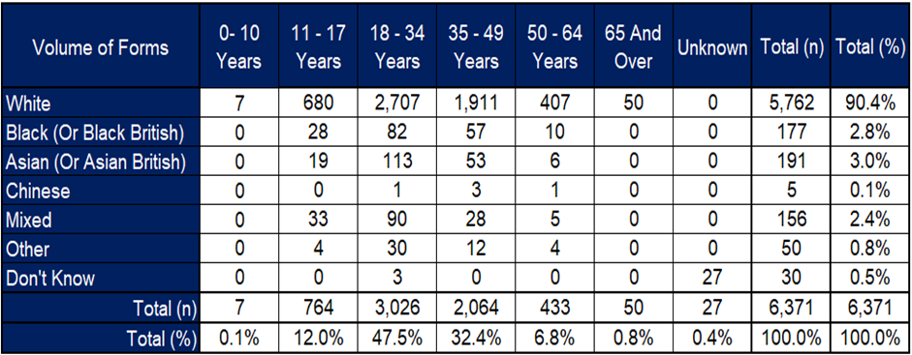

The below table is based on all tactics used by all officers. As already stated, multiple officers may use force during the same incident and each officer may use more than one tactic. Officers must fill out the form in the order the tactics were used.

In 2023/24, from the 6371 forms submitted, it was identified that a total of 9583 tactics were used. The most used tactic was Compliant Handcuffing, which was used a total of 3272 times, accounting for 34.1% of all tactics used. Unarmed Skills was the second most used tactic and was used 1748 (18.2%) times, followed by Non-Compliant Handcuffing which was used 1536(16%) times. Compliant Handcuffing was the most used primary tactic and was selected as tactic 1 on a total of 2950 forms.

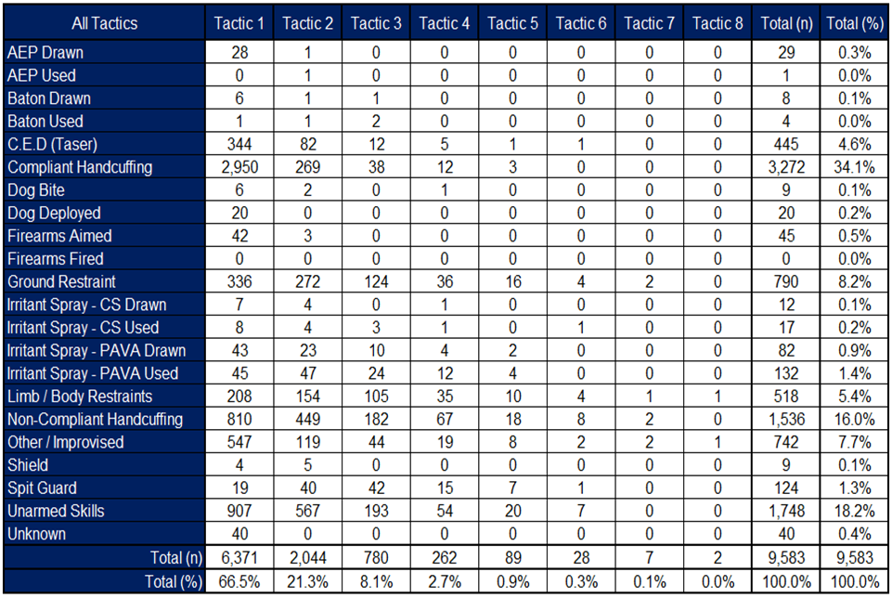

The below table is based on the total amount of tactics used and broken down by the age of the individual the form is relating to. Individuals may be counted multiple times if more than one Officer submitted a form relating to that individual and if more than one tactic was used. This figure cannot be based on the number of individuals, because if multiple Officers used force on one individual, they may have used different tactics, and each tactic needs to be accounted for.

Compliant handcuffing was the most common tactic used across most of the age groups. C.E.D (Taser) was used as a tactic on a subject aged 11-17 years a total of 40 times. There is robust scrutiny via a review process carried out in all cases where this tactic is used on a child under the age of 18 years. There were no discharges of the C.E.D (Taser) on a child during 2023/2024.

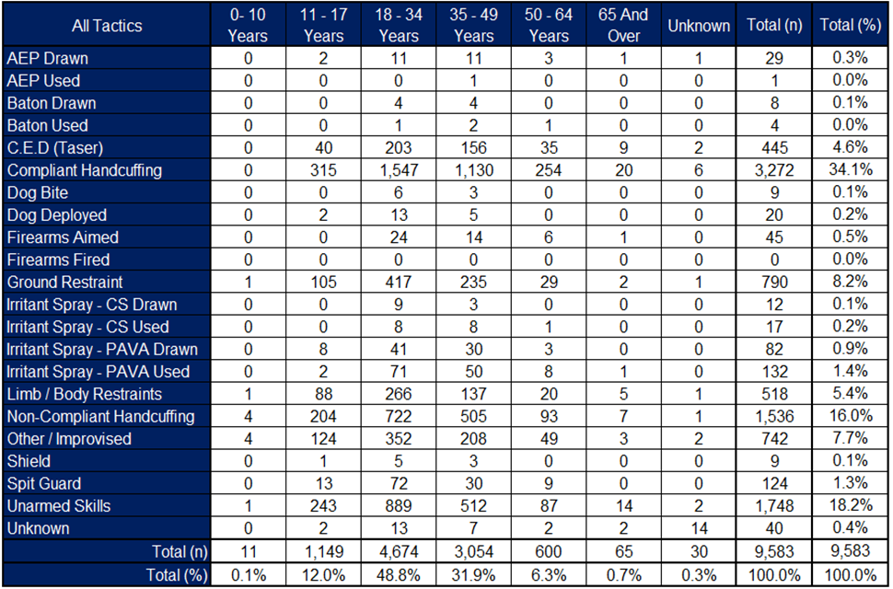

The below table is the amount of tactics used broken down by ethnicity (Officer perceived) of the individual the form is relating to.

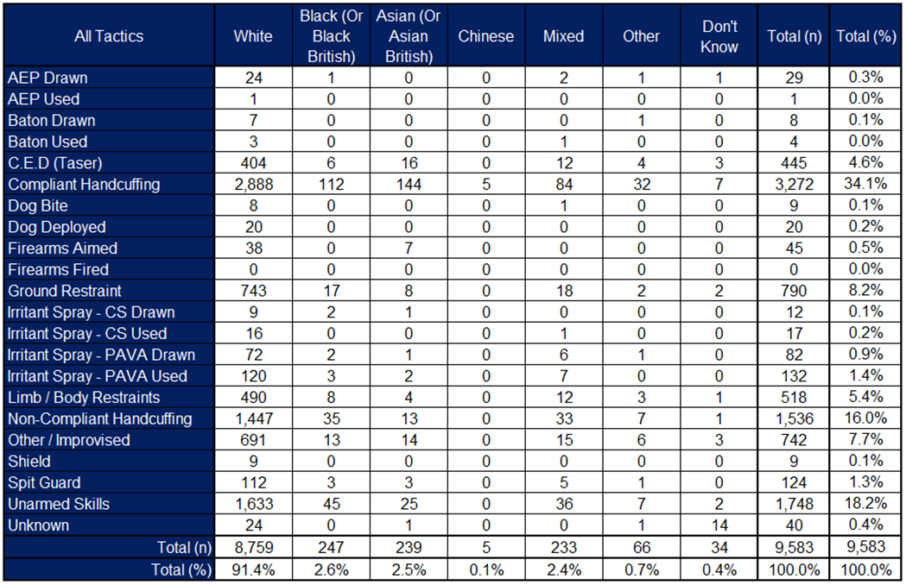

Individuals may be counted multiple times if more than one Officer submitted a form relating to the individual and if more than one tactic was used. Again, it is pertinent to note that this figure cannot be based on the number of individuals because if multiple Officers used force on one individual, they may have used different tactics, and each tactic needs to be accounted for.

In 2023/24 the most used tactic across each of the ethnic heritage groups was Compliant Handcuffing.

Use of Force future focus and next steps:

* Continue development into understanding factors of disproportionality in use of force.
* Identify and implement additional opportunities for capturing feedback from communities regarding their experiences of use of force inclusive of young people.
* Development of additional information regarding C.E.D (Taser) use.

**7. PERSONNEL CONSIDERATIONS**

None

**8. LEGAL CONSIDERATIONS**

None

**9. EQUALITIES & HUMAN RIGHTS CONSIDERATIONS**

* This report has been considered against the general duty to promote equality, as stipulated under the Joint Strategic Equality Plan and has been assessed not to discriminate against any particular group.
* In preparing this report, consideration has been given to requirements of the Articles contained in the European Convention on Human Rights and the Human Rights Act 1998.

**10. RISK**

None

**11. PUBLIC INTEREST**

* In producing this report, has consideration been given to ‘public confidence’? Yes
* Are the contents of this report, observations, and appendices necessary and suitable for the public domain? Yes
* If you consider this report to be exempt from the public domain, please state the reasons: (not applicable)
* Media, Stakeholder and Community Impacts:

**12. REPORT AUTHOR**

Chief Superintendent Leanne Brustad

**13. LEAD CHIEF OFFICER**

DCC Nicola Brain

**14. ANNEXES**

Nil

**15. CHIEF OFFICER APPROVAL**

* I confirm this report has been discussed and approved at a formal Chief Officers’ meeting on 14.11.24
* I confirm this report is suitable for the public domain / ~~is not suitable~~ for the public domain for the reasons stated in 11.3.

Signature: 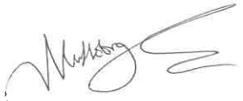  
 Date: 15.11.24