Keep Safe Cymru Card
The Office of the Police and Crime Commissioner and Gwent Police have jointly implemented a Keep Safe Card Scheme for anyone in the Gwent Police area with a communication need.
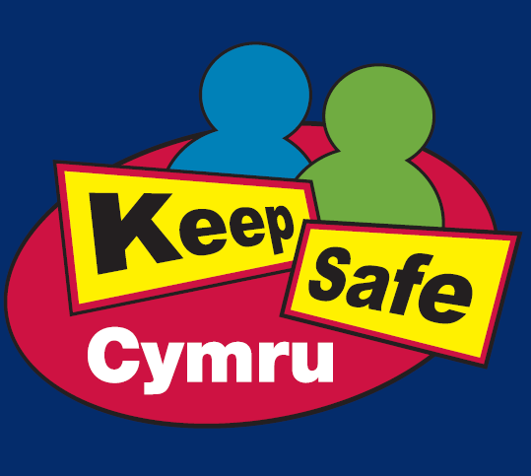
In developing the scheme locally, we have worked with the National Autistic Society, and Torfaen, Monmouthshire and Newport People First groups to understand the difficulties people experience when contacting or speaking to the police.
People with a communication difficulty or learning disability are less likely to contact the police themselves. The Keep Safe Card Scheme will help people feel more able to speak to the police to report crime - especially hate crime - and seek help when they need it. It will also help those providing assistance, such as the police, to access support for the user of the card and understand how to make them feel safer.
If the card holder needs help, whether they are lost, a victim of crime or are in any situation that means they need some extra support, the police can access basic information about the individual, such as how they communicate, their support needs, any health issues and any emergency contacts such as parents or carers.
When speaking to the police on the phone, the call handler will be able to access information provided by the individual. This will ensure that the call handler is aware of any additional needs the caller may have and can pass this information on to any police officers or staff engaging with or supporting the individual.
To join this scheme, please complete a registration form. You can do this in one of three ways:
- Download the Keep Safe Cymru Registration Form and return by post
- Complete the form online – online form link
- Ask for the forms to be sent out to you by post – our contact details are:
Telephone: 01633 247941
E-mail: DiversityandInclusion@gwent.pnn.police.uk

Upon the receipt of a completed form, a Keep Safe Card information pack will be sent to the new cardholder or their carer, and they may begin using it straight away. The information provided on the registration form is for police use only and will not be shared with any third parties.

