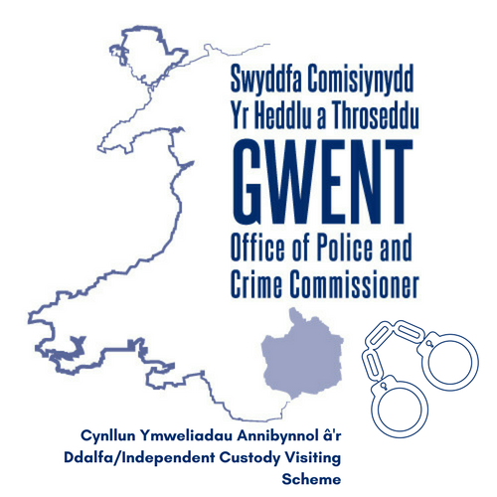

Reprisals Policy
Custody Visiting

Independent Custody visitors are volunteers who make unannounced visits to detainees in police custody to ensure the rights, entitlements and wellbeing of detainees are being met by the force. The Office of Police and Crime Commissioner for Gwent has a responsibility to ensure that detainees are able to speak to independent custody visitors openly and without fear of reprisals from the force as part of its responsibility under the Optional Protocol to the Convention against Torture and Other Cruel, Inhuman or Degrading Treatment or Punishment (OPCAT). OPCAT is an international human rights treaty designed to strengthen the protection of people deprived of their liberty.

The process

- Should a detainee feel that they have suffered a reprisal having spoken to an independent custody visitor this should be raised within the complaints process which should be clearly advertised in all custody suites and on relevant websites.
https://www.gwent.police.uk/contact-us/your-opinion-counts/making-a-complaint/

- Where a detainee alerts an independent custody visitor to a reprisal, or fear of a reprisal, the custody visitor will include this in their report to the scheme manager at the Office of Police and Crime Commissioner for Gwent.

- The force has agreed to escalate complaints with specific reference to reprisals from an interaction with an independent custody visitor to The Office of Police and Crime Commissioner for Gwent.

- Where there has been an allegation of a reprisals incident the Office of Police and Crime Commissioner for Gwent will investigate this incident fully.

- Where there has been an allegation of a reprisals incident the Office of Police and Crime Commissioner for Gwent will report the alleged incident to the Independent Custody Visiting Association, (ICVA) and the outcome of any investigations.

- Should an allegation of a reprisal be proved, the Office of Police and Crime Commissioner for Gwent will ensure that the appropriate steps are taken to deal with the instance with the force, and that there are steps in place to ensure the avoidance of future reprisals.

Should you have any questions or concerns regarding the reprisals policy, please email: commissioner@gwent.pnn.police.uk

